**Cardiff Metropolitan University**

**B.Sc. (Hons) in Business Information Systems**

**Assignment Cover Sheet**

|  |  |  |  |  |  |  |  |  |  |
| --- | --- | --- | --- | --- | --- | --- | --- | --- | --- |
| **Student Details (Student should fill the content)** | | | | | | | | | |
| Name | | | Hasitha Piyumal Bandaranayake | | | | | | |
| Student ID | | | ST20208731 | | | | | | |
| **Scheduled unit details** | | | | | | | | | |
| Unit code | | | CIS6008 | | | | | | |
| Unit title | | | Analytics and Business Intelligence | | | | | | |
| Unit enrolment details | | | Year | | | 3 | | | |
| Study period | | | 2023 | | | |
| Lecturer | | | Assignment prepared by Induranga De Silva | | | | | | |
| Mode of delivery | | | Full Time | | | | | | |
| **Assignment Details** | | | | | | | | | |
| Nature of the Assessment | | | Coursework (a report) | | | | | | |
| Topic of the Case Study | | | Application of statistical and geospatial business analytics tools, techniques and methodologies to generate business intelligence essential for informed decision making in Power and Renewable Energy sector credible, efficient and effective informed decision making in Sri Lanka. | | | | | | |
| Learning Outcomes covered | | | LO2, LO3, LO4 | | | | | | |
| Word count | | | 3200(report) | | | | | | |
| Due date / Time | | | 31st August 2023 | | | | | | |
| Extension granted? | | | Yes | No | | Extension Date | |  | |
| Is this a resubmission? | | | Yes | No | | Resubmission Date | |  | |
| **Declaration** | | | | | | | | | |
| I certify that the attached material is my original work. No other person’s work or ideas have been used without acknowledgement. Except where I have clearly stated that I have used some of this material elsewhere, I have not presented it for examination / assessment in any other course or unit at this or any other institution | | | | | | | | | |
| Name/Signature | | | Hasitha | | Date | | | 05/09/2023 | |
| **Submission** | | | | | | | | | |
| Return to: | | |  | | | | | | |
| **Result** | | | | | | | | | |
| Marks by 1st Assessor |  | Name & Signature of the 1st Assessor | | | | |  | | **Agreed Mark** |
| Marks by2nd Assessor |  | Name & Signature of the 2nd Assessor | | | | |  | |
| Comments on the Agreed mark |  | | | | | | | | |

**CMU B.Sc. (HONS) BIS - ASSIGNMENT FEEDBACK SHEET –ICBT CAMPUS**

|  |  |  |  |  |  |  |  |  |
| --- | --- | --- | --- | --- | --- | --- | --- | --- |
| **STUDENT NAME: Hasitha Piyumal Bandaranayake** | | | | | | **STUDENT NUMBER: ST20208731** | | |
| **Module Number & Title**: Analytics and Business Intelligence | | | | | | **Semester: II** | | |
| **Assignment Type & Title**: Coursework  Application of statistical and geospatial business analytics tools, techniques, and methodologies to generate business intelligence essential for informed decision making in Power and Renewable Energy sector credible, efficient, and effective informed decision making in Sri Lanka. | | | | | | | | |
| **For student use:** Critical feedback on the individual progression towards achieving the assignment outcomes | | | | | | | | |
|  | | | | | | | | |
| **For the Assessors’ feedback**  **Indicate the Task number strength and Weaknesses and the marks for each task** | | | | | | | | |
| Task No/Question No | | Strengths (1st Assessor) | | | | | | Strengths (2nd Assessor) |
| **Task No / Question No** | | Weaknesses (1st Assessor) | | | | | | Weaknesses (2nd Assessor) |
| **Areas for future improvement** | | | | | | | | |
| Comments by 1st Assessor | | | | | | | | Comments by 2nd Assessor |
| **Marks** | | | | | | | | |
| **Task /Question No** | **Marks by 1st Assessor** | | **Marks by 2nd Assessor** | | **Marks by IV (if any)** | | **IV comments (If Any)** | |
|  |  | |  | |  | |  | |
|  |  | |  | |  | |
|  |  | |  | |  | |
| Total Marks |  | |  | |  | |
| Name and the Signature of the 1st Assessor | | | |  | | Date: | |  |
| Name & Signature of the 2ndAssessor: | | | |  | | Date: | |  |
| Name & Signature of the IV: (If any) | | | |  | | Date: | |  |

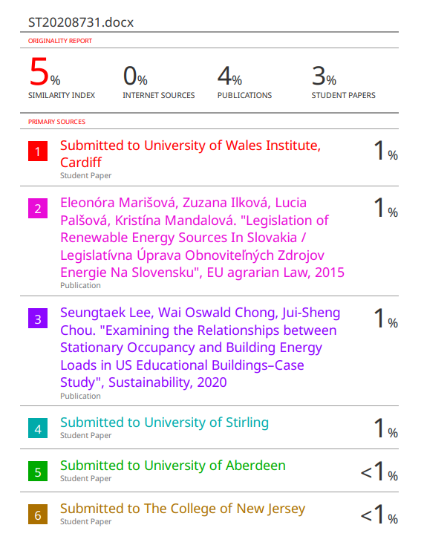

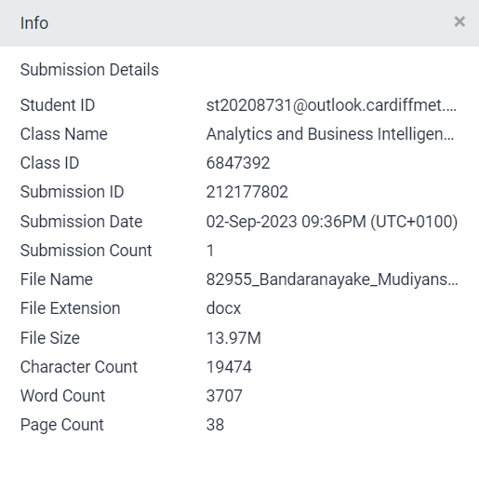

# ACKNOWLEDGEMENT

Foremost, we the students of BSc in Computing & Software Engineering, batch 10 would like to express our sincere gratitude and appreciation to Mr. Asanka Dinesh, lecturer in Analytics and Business Intelligence for him continuous support, patience, motivation, enthusiasm, and immense Besides our lecturer, we would like to thank our seniors, who had been providing guidance and support for the completion of our assignment and presentation.

Moreover, we would like to express gratitude and appreciation to each other for providing continuous support, enthusiasm, and knowledge in completing the project, assignment.

Further, we would like to express our gratitude to all the ICBT management and staff for being extremely friendly, welcoming and for providing us with this opportunity to present our talents and ideas via an assignment and a presentation. Finally, I would like to express our sincere gratitude to our families for providing moral support and a positive environment throughout the journey.

# EXECUTIVE SUMMARY

Sri Lanka's Ministry of Electricity and Renewable Energy is proactively addressing the escalating electricity demand through a multifaceted research project. By analyzing data on building structural and cooling factors, accurate statistical models are being developed to enhance energy efficiency and reduce wastage. Additionally, the identification of feasible land for wind and solar power plants using GIS technology showcases the country's commitment to sustainable energy generation. The digitization of solar power plants and buildings on maps ensures precise planning, while the creation of a comprehensive database for fuel consumption aids in informed decision-making. Together, these efforts form a strategic initiative to reduce energy demand and increase sustainability in Sri Lanka.

# TABLE OF CONTENTS

ACKNOWLEDGEMENT V

EXECUTIVE SUMMARY VI

TABLE OF CONTENTS VII

INTRODUCTION 1

Chapter 1 3

1.1. Essential steps before data analytics 3

1.2. Bell curve for Cooling Load 4

1.3. Scatter Plot 5

1.4. Create Model 6

1.5. Identifying Relationships 7

1.5.1. Cooling Load and Heating Load Relationship 7

1.5.2. Cooling Load and Glazing Area Relationship 7

1.5.3. Cooling Load and Overall Height Relationship 8

1.5.4. Cooling Load and Relative Compactness Relationship 9

Chapter 2 10

**2.** 10

2.1. Cooling_Load and Heating_Load 10

2.1.1. Summary Statistic for lm () Function 10

2.2. Cooling_Load and Glazing_Area 11

2.2.1. Summary Statistic for lm () Function 11

2.3. Cooling_Load and Relative_Compactness 12

2.3.1. Summary Statistic for lm () Function 12

2.4. Cooling_Load and Overall_Height 13

2.4.1. Summary Statistic for lm () Function 13

Chapter 3 14

Chapter 4 18

Chapter 5 21

Chapter 6 24

Chapter 7 28

Chapter 8 34

CONCLUSION 37

APPENDIX ii

# LIST OF FIGURES

Figure 1.1Data preprocessing 3

Figure 1.2Categorical and Continuous value 3

Figure 1.3 Bell curve for cooling load 4

Figure 1.4 Scatter Plot 5

Figure 1.5 linear regression model 6

Figure 1.6 summary of linear regression 6

Figure 1.7Cooling Load and Heating Load Relationship 7

Figure 1.8Cooling Load and Glazing Area Relationship 7

Figure 1.9Cooling Load and Overall Height Relationship 8

Figure 1.10Cooling Load and Relative Compactness Relationship 9

Figure 2.1lm () function for Cooling Load and Heating Load 10

Figure 2.2Summary statistic function for the given lm () function 10

Figure 2.3lm () function for Cooling_Load and Glazing_Area 11

Figure 2.4Summary statistic function for the given lm () function 11

Figure 2.5lm () function for Cooling_Load and Relative_Compactness 12

Figure 2.6Summary statistic function for the given lm () function 12

Figure 2.7lm () function for Cooling_Load and Overall_Height 13

Figure 2.8Summary statistic function for the given lm () function 13

Figure 3.1SLWindPowerLand_21_23 Dataset 14

Figure 3.2Feasible land for Wind Power development 15

Figure 3.3Feasible land for Wind Power development (pie chart) 17

Figure 4.1Estimated Energy dataset 18

Figure 4.2Usable land for Solar Power development 19

Figure 5.1Digitized Map of Solar Power Plants in Hambantota 22

Figure 6.1Number of sheds, Gasoline, and diesel dataset 24

Figure 6.2Descriptive Statics on Gasoline and Diesel Sheds - 2023 25

Figure 6.3Descriptive Statics on Diesel Usage - 2023 26

Figure 7.1Potential Locations For Renewable Energy Generation In Sri Lanka 29

Figure 7.2Potential Locations for Solar Power Generation In Sri Lanka 30

Figure 7.3Potential Locations for Wind Power Generation In Sri Lanka 31

Figure 7.4Potential Locations for Biomass Power Generation in Sri Lanka 32

Figure 8.1Regional Renewable Energy Research Centre - Kandy 34

Figure 8.2Regional Renewable Energy Research Centre - Kandy 35

# LIST OF TABLES

Table 8.1Suitable Area for Research centre In Kandy 36

# ABBREVIATIONS

|  |  |
| --- | --- |
| DAM | Digitized Area Map |
| DEA | Data Analysis and Visualization for Energy Efficiency |
| DSM | Development of Statistical Models |
| REGM | Renewable Energy Generation Locations Map |
| SPDM | Solar Power Development Map |
| WPDM | Wind Power Development Map |

# ABSTRACT

This research project, commissioned by Sri Lanka's Ministry of Electricity and Renewable Energy, employs data analysis, GIS technology, and strategic planning to enhance energy efficiency and promote renewable energy sources. Through statistical modeling, land suitability assessments, digitization of assets, and database creation, the project aims to reduce energy demand and drive sustainable energy solutions. This multifaceted approach provides a comprehensive strategy for a greener and more resilient energy future in Sri Lanka

# INTRODUCTION

Sri Lanka's electricity demand is increasing day by day. But the Ministry of Energy in this country is unable to supply the demand. This assignment is based on a research project presented by the Ministry of Electricity and Renewable Energy to solve the energy problem in Sri Lanka. The task is as follows. Building structural factors related to the shape of a building determine the time it takes to cool the building and the duration of cooling. If these factors are in place in a building, chillers can operate more efficiently and use less electricity. Otherwise, the electricity is completely wasted. This contributes significantly to the overall electricity demand. A dataset named "energy_efficiency_data.csv" containing the above structural factors is provided.

In the first and second task, accurate statistical models are created based on the structural factors and cooling factors of a building using the R programming language and the data set mentioned above and data analysis is performed. At the end of this analysis, it is hoped to identify the relationships between cooling systems, building structures and energy consumption. The main objective is to reduce Sri Lanka's energy demand and increase energy efficiency.

In the third task, using the "SLWindPowerLand_21_23.csv" data set, a visual representation of the feasible land for the construction of new wind power plants in Sri Lanka is created. The QGIS application is used to accomplish this task. Here, the viable lands available in each district is shown on a map.

In the fourth task, suitable land for solar power plant construction is displayed on a map using the given data as in the third task above. Districts are classified and represented on a map based on the estimated total energy generation of each district. Details like district name, total area, etc. appear on the map.

In the fifth task, the Google Earth aerial image or information about solar power plants and buildings on the map is digitized using QGIS.

In the sixth task, a database is created in the PostgreSQL application using statistical data including monthly petrol and diesel consumption. This database includes the number of sheds, average diesel usage and average petrol usage for each district. A classification map is created with this data.

In the seventh task, suitable sites for renewable energy generation in Sri Lanka are identified using Google Earth and mapped using QGIS.

In the final task, a suitable land is selected for the construction of a regional research centre in the Kandy area and a map containing information about the area and the suitable area is displayed using QGIS.

# 

**QUESTION A**

Analyzes how factors such as cooling systems and building structures affect energy consumption. The purpose of this machine is to cool buildings more efficiently and reduce electricity demand. Here R-studio application is used to perform this analysis. The variables in the data set can be divided into categorical and continuous.

### Essential steps before data analytics

First the file containing the dataset needs to be uploaded to R-Studio. As a mandatory step, data cleaning should be done next. In this step, the null values in the data set are removed. After that we can start analyzing the data. Below are the codes used for that.

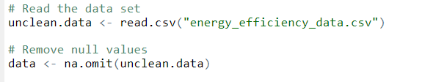

Figure 1.1Data preprocessing

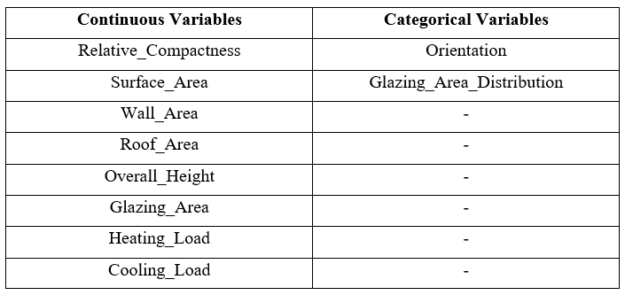

Figure 1.2Categorical and Continuous value

The above shows that the variables in the input data set are categorical and continuous.

### Bell curve for Cooling Load

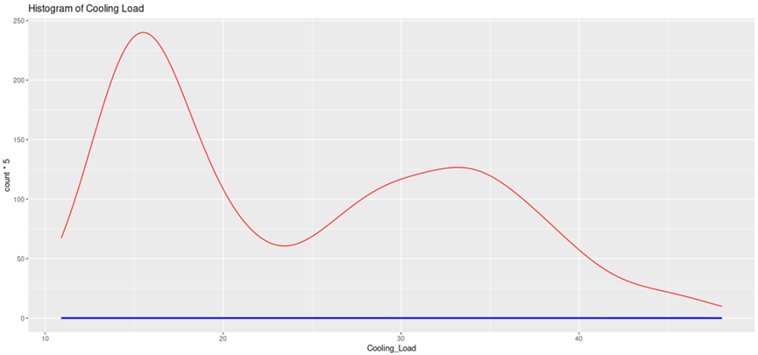

Figure 1.3 Bell curve for cooling load

The figure above shows a bell curve showing the distribution of data in the data set used for this data analysis(PhD, 2022). This curve was created using the standard deviation of the data file. The peak of this bell curve represents the average value or mean. This can also be described as a multivariate distribution.

### Scatter Plot

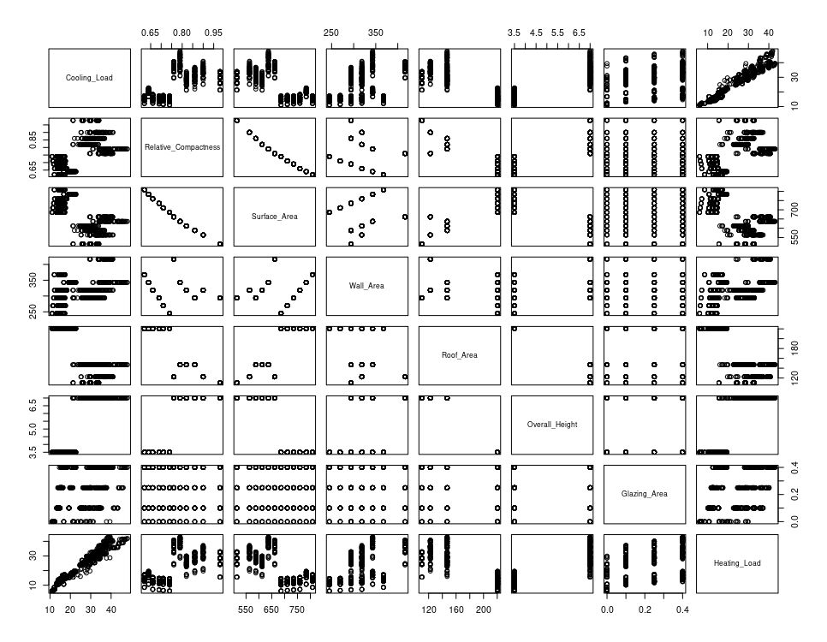

Figure 1.4 Scatter Plot

Above is a scatterplot drawn including structural factors affecting the cooling of a building. Here the main objective is to show the relationship between the cooling load and the relevant structural factor. According to the figure above, the connections are as follows. As the first relationship there is a positive relationship between the cooling load and the heating load. There is a negative relationship between the variables surface area and relative compactness, wall area and relative compactness. Finally, there is a positive relationship between surface area and wall area.

### Create Model



Figure 1.5 linear regression model

A model should be developed to examine the relationship between Cooling_Load and other variables. The model created for that is shown above.

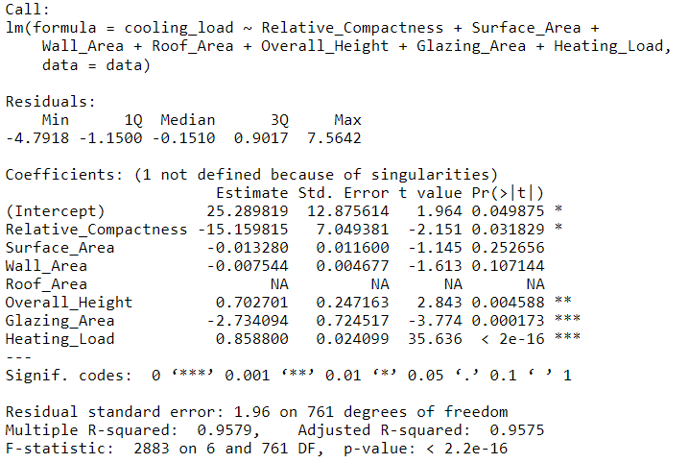

Figure 1.6 summary of linear regression

In accordance with the model created above the relationship between Cooling_Load and the above-mentioned variables is analyzed below. Below is the summary of the linear regression model. This confirms the relationships in the scatterplot presented earlier. The relationships thus identified can be stated as follows. They are the variables Cooling_Load along with Glazing_Area, overall_Height, Relative_compactness, Heating Load. On this summary it appears that there is a very good relationship between Cooling_Load and Heating Load.

### Identifying Relationships

#### Cooling Load and Heating Load Relationship

H0: There is no significant relationship between the cooling load and the heating load of the building.

H1: There is a significant relationship between the cooling load and the heating load of the building.

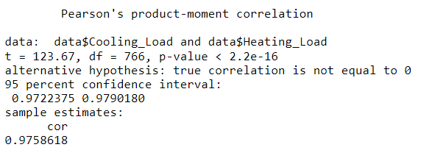

Figure 1.7Cooling Load and Heating Load Relationship

As shown in the figure above, the P-value corresponding to the two variables Cooling_Load and Heating_Load is 2.2e-16. The significance level is 0.05. This means that there is a good correlation between these 2 variables and therefore the null hypothesis can be removed.

#### Cooling Load and Glazing Area Relationship

H0: There is no significant relationship between the cooling load and the Glazing Area of the building.

H1: There is a significant relationship between the cooling load and the Glazing Area of the building.

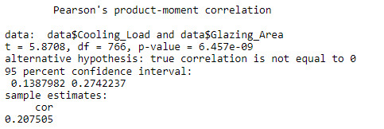

Figure 1.8Cooling Load and Glazing Area Relationship

As shown in the figure above, the P-value corresponding to the two variables Cooling_Load and Glazing Area is 6.457e-09. The significance level is 0.05. This means that there is a good correlation between these 2 variables and therefore the null hypothesis can be removed.

#### Cooling Load and Overall Height Relationship

H0: There is no significant relationship between the cooling load and the Overall Height of the building.

H1: There is a significant relationship between the cooling load and the Overall Height of the building.

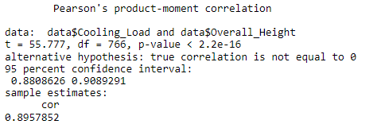

Figure 1.9Cooling Load and Overall Height Relationship

The P-value corresponding to the two variables Cooling_Load and Overall Height is 2.2e-16. The significance level is 0.05. This means that there is a good correlation between these 2 variables and therefore the null hypothesis can be removed.

#### Cooling Load and Relative Compactness Relationship

H0: There is no significant relationship between the cooling load and the Overall Height of the building.

H1: There is a significant relationship between the cooling load and the Overall Height of the building.

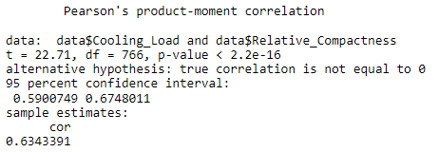

Figure 1.10Cooling Load and Relative Compactness Relationship

Considering Cooling_Load and Relative_Compactness, p-value = 2.2e-16 and the value is less than 0.05, so it seems that there is a good relationship between Cooling_Load and Relative_Compactness. Therefore, the null hypothesis is rejected, and the Alternative Hypothesis is confirmed to be correct.

# 

**QUESTION B**

In this work, a statistical model is developed for the relationships identified in the first method above. The main purpose of this is to form this model of the relationships identified above and then present a summary statistic.

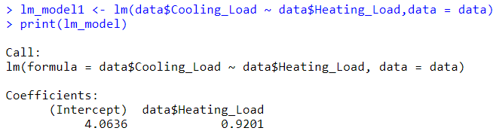

Figure 2.1lm () function for Cooling Load and Heating Load

### Cooling_Load and Heating_Load

$$Y data\$cooling_Load= 4.0636+ 0.9201 X data\$Heating_Load$$

#### Summary Statistic for lm () Function

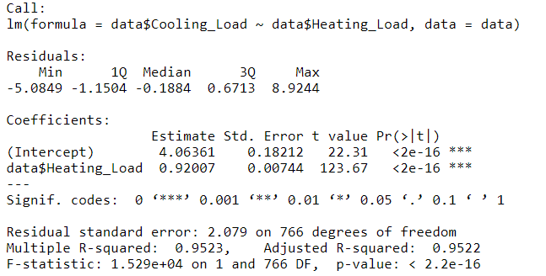

Figure 2.2Summary statistic function for the given lm () function

According to the above summary statistics, there is a very strong correlation between the two variables Cooling_Load and Heating_Load. The P-value here is very small. That is 2.2e-16.

### Cooling_Load and Glazing_Area

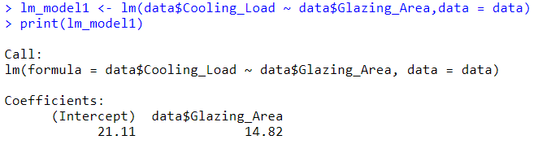

Figure 2.3lm () function for Cooling_Load and Glazing_Area

$$Y data\$cooling_Load= 21.11+ 14.82 X data\$Glazing_Area$$

#### Summary Statistic for lm () Function

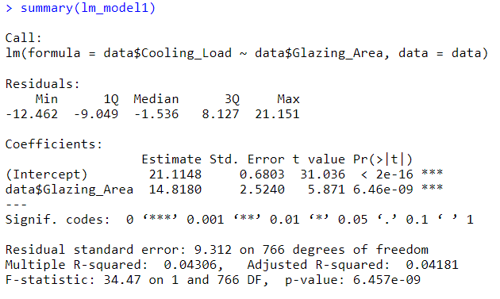

Figure 2.4Summary statistic function for the given lm () function

A p-value of 6.457e-09 was obtained for the relationship between Cooling_Load and Glazing_Area as in the above relationship.

### Cooling_Load and Relative_Compactness

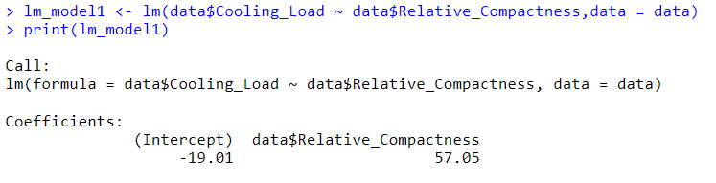

Figure 2.5lm () function for Cooling_Load and Relative_Compactness

$$Y data\$cooling_Load= -19.01+ 57.05X data\$Relative_Compactnes$$

#### Summary Statistic for lm () Function

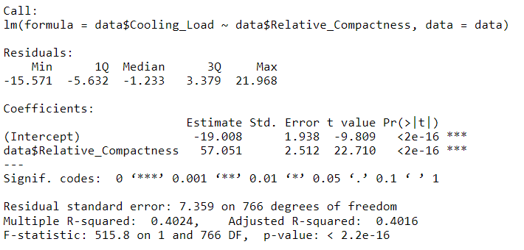

Figure 2.6Summary statistic function for the given lm () function

According to the summary statistics, there is a very strong correlation between the two variables Cooling_Load and Relative_Compactness. Here the P value is very small. That is 2.2e-16.

### Cooling_Load and Overall_Height

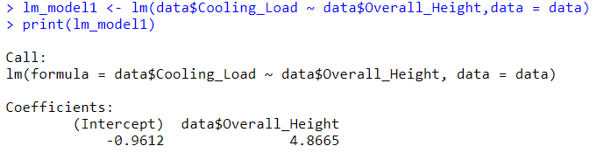

Figure 2.7lm () function for Cooling_Load and Overall_Height

$$Y data\$cooling_Load= -0.9612+ 4.86X data\$Overall_Hight$$

#### Summary Statistic for lm () Function

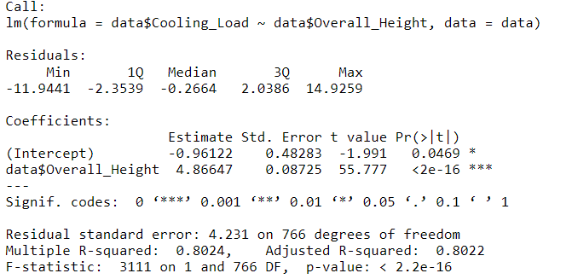

Figure 2.8Summary statistic function for the given lm () function

According to the summary statistics, there is a very strong correlation between the two variables Cooling_Load and Overall_Height. Here the P value is very small. That is 2.2e-16.

# 

**QUESTION C**

Currently, the focus is on the use of renewable energy. In this chapter, attention is focused on wind energy as a renewable energy source and the search for suitable land for the development of wind power plants in Sri Lanka is carried out. Then the land suitable for the development of wind power plants is displayed on a map of Sri Lanka separately from district to district. This work is done using the dataset published by Sri Lanka Sunitya Energy Authority named "SLWindPowerLand_21_23.csv"(Rodrigo, n.d.), (Sri Lanka Sustainable Energy Authority, 2023). Below is a screenshot of the dataset I mentioned above.

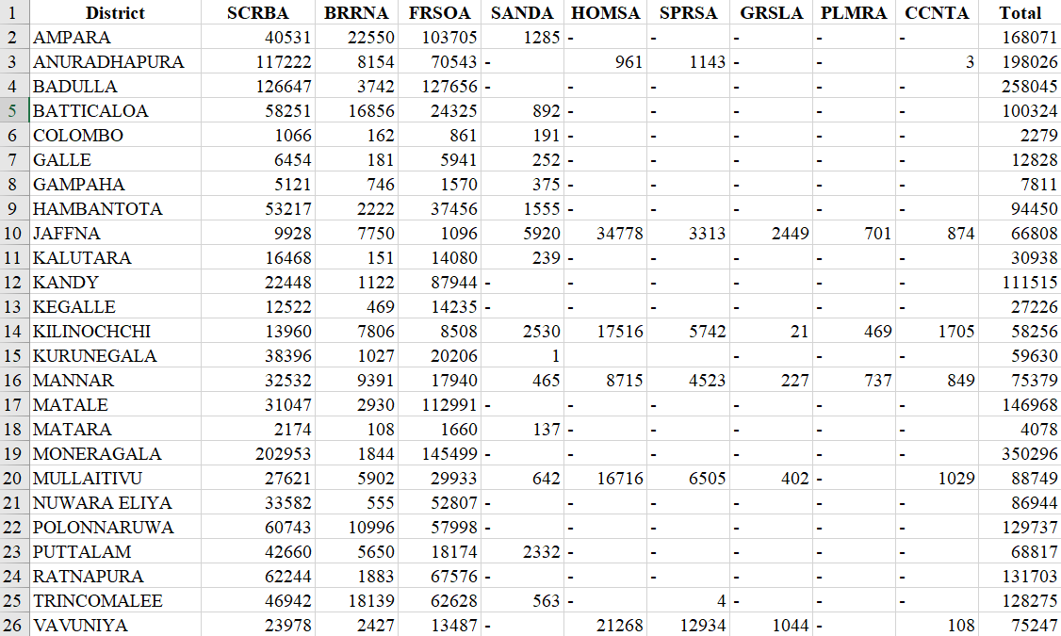

Figure 3.1SLWindPowerLand_21_23 Dataset

A map of Sri Lanka with suitable land for wind power development shows the related explanation below.

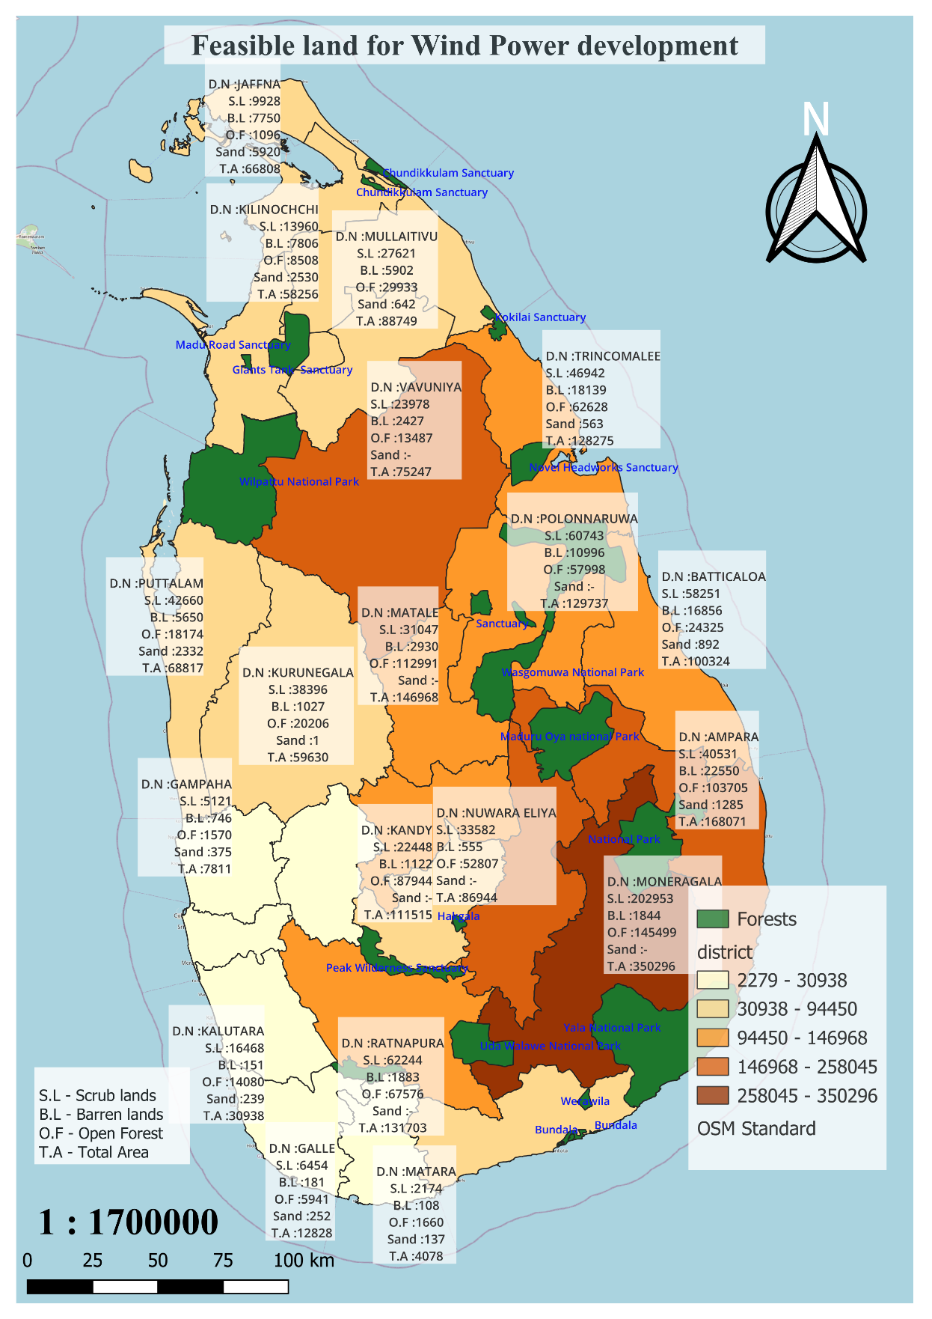

Figure 3.2Feasible land for Wind Power development

Above is a map of Sri Lanka that visualizes information about potential land drawn using the given data set. This map is divided by districts. Districts on the map are colored in a range of colors from light to dark. Accordingly, the district with the strongest color is the most suitable district for wind power generation, and in comparison, the decrease in color in other districts implies that the feasibility of developing wind power plants is gradually decreasing. That is, the dark color shows the district with the highest potential for wind power development and the white color shows the least potential for wind power development. And the green color shows the existing forests in Sri Lanka. Also, open forest, scrub, wasteland and sand areas are grouped on the map.

According to the above map, there are several districts suitable for the development of wind farms. They are Anuradhapura, Monaragala, Ampara, Badulla. Before constructing a wind farm, a feasibility study is carried out in the area. The main requirements that are considered are as follows. Examples of these are spacing between wind turbines, setbacks from obstacles, access roads and infrastructure, wind resource variability, buffer zones, non-sand areas. Considering these factors, Monaragala can be said to be the most suitable district for the construction of wind power plants. Monaragala district has no sandy land and has a large area of 350296 hectares. That is, the basic requirements to build a wind farm are met.

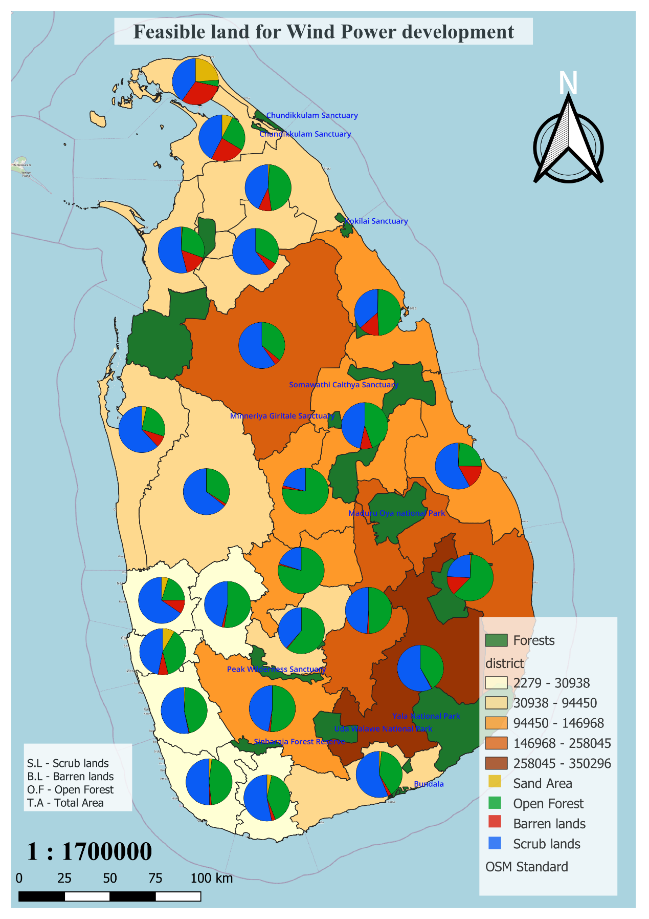

Figure 3.3Feasible land for Wind Power development (pie chart)

# 

**QUESTION D**

As mentioned in the above chapter, solar energy can be called as another renewable energy. Sri Lanka is a country close to the equator. Therefore, the sun shines throughout the year. In this chapter, the data set provided by the Sri Lanka Renewable Energy Authority should be used to find and map the most suitable land to build the solar power plant in Sri Lanka. Using the given data, a data set is created which includes district, total capacity (MW), total area (ha), and total estimated energy (GWh) etc. Below is a screenshot of the data set I mentioned above.

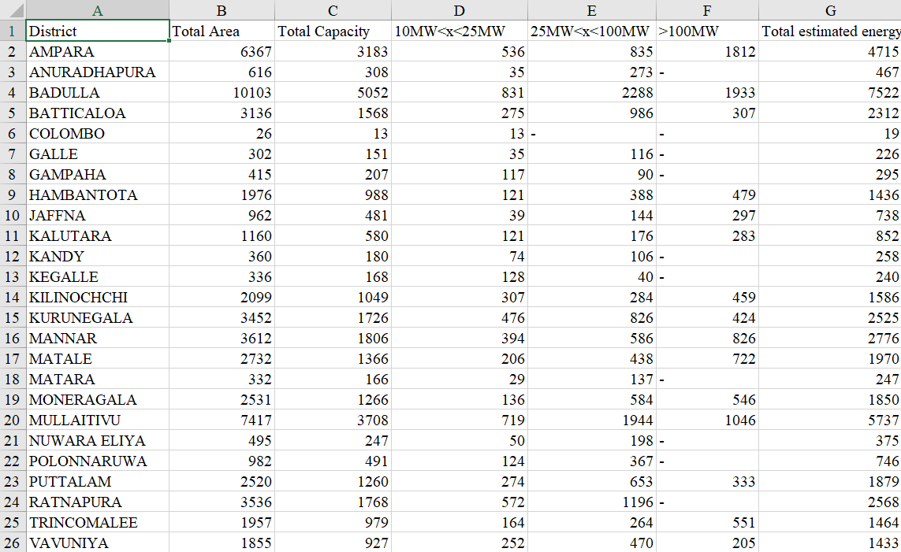

Figure 4.1Estimated Energy dataset

The above data set shows the power generation capacities of different districts. The energy requirement varies from district to district. It implies that power plant facilities have been provided from small size to large size in accordance with each district. The above table shows the contribution of each district to the total energy supply of the nation.

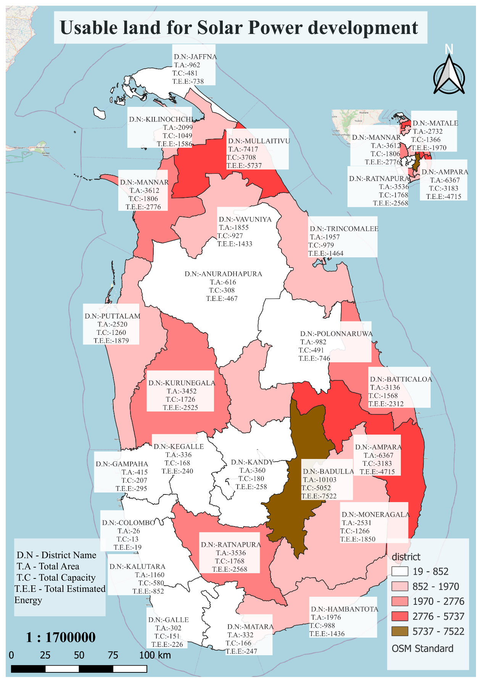

Figure 4.2Usable land for Solar Power development

The above map shows a map of Sri Lanka divided according to the districts that include the land available for the construction of solar power plants. Districts are colored by estimated strength. It is clearly mentioned in the legend of the map. Mainly speaking, the district with the darkest color is the most suitable district for the generation of electricity from solar energy, and the decrease in the color of other districts in comparison shows that the feasibility of developing solar power plants is gradually decreasing. Districts with the least amount of energy produced by solar power plants are shown in white.

By studying the above map, the following conclusions can be drawn. We can see that Badulla district can generate a high amount of electricity in terms of energy if solar power plants are built in the above manner throughout the country. An amount of 10103 hectares of land has been identified in Badulla district. The Renewable Energy Authority has identified this as having a total capacity of 5052 MW with an estimated total energy of 7522GWh. Compared to Badulla, the next most suitable districts to produce the most electricity are Ampara and Mullaitivu. The estimated total energy of these two districts is 4715GWh and 5737GWh respectively. According to the map, the second largest energy producing district is Ampara and the third is Mullaitivu.

By gaining an understanding of these processes, Sri Lanka's electricity supply can be further developed by using the country's resources efficiently. It can bring reliable energy supply across the country.

# 

**QUESTION E**

This chapter uses GIS tools and Google Earth imagery to develop and explore a digital map for the integration of solar power plants in an island energy landscape. This map shows roads, trees, solar facilities, buildings, and forests in different layers. The main purpose of analyzing spatial relationships is to demonstrate how solar power can contribute to improving energy security and fueling economic growth. This chapter critically examines the progress in the use of solar energy to overcome challenges in the energy sector

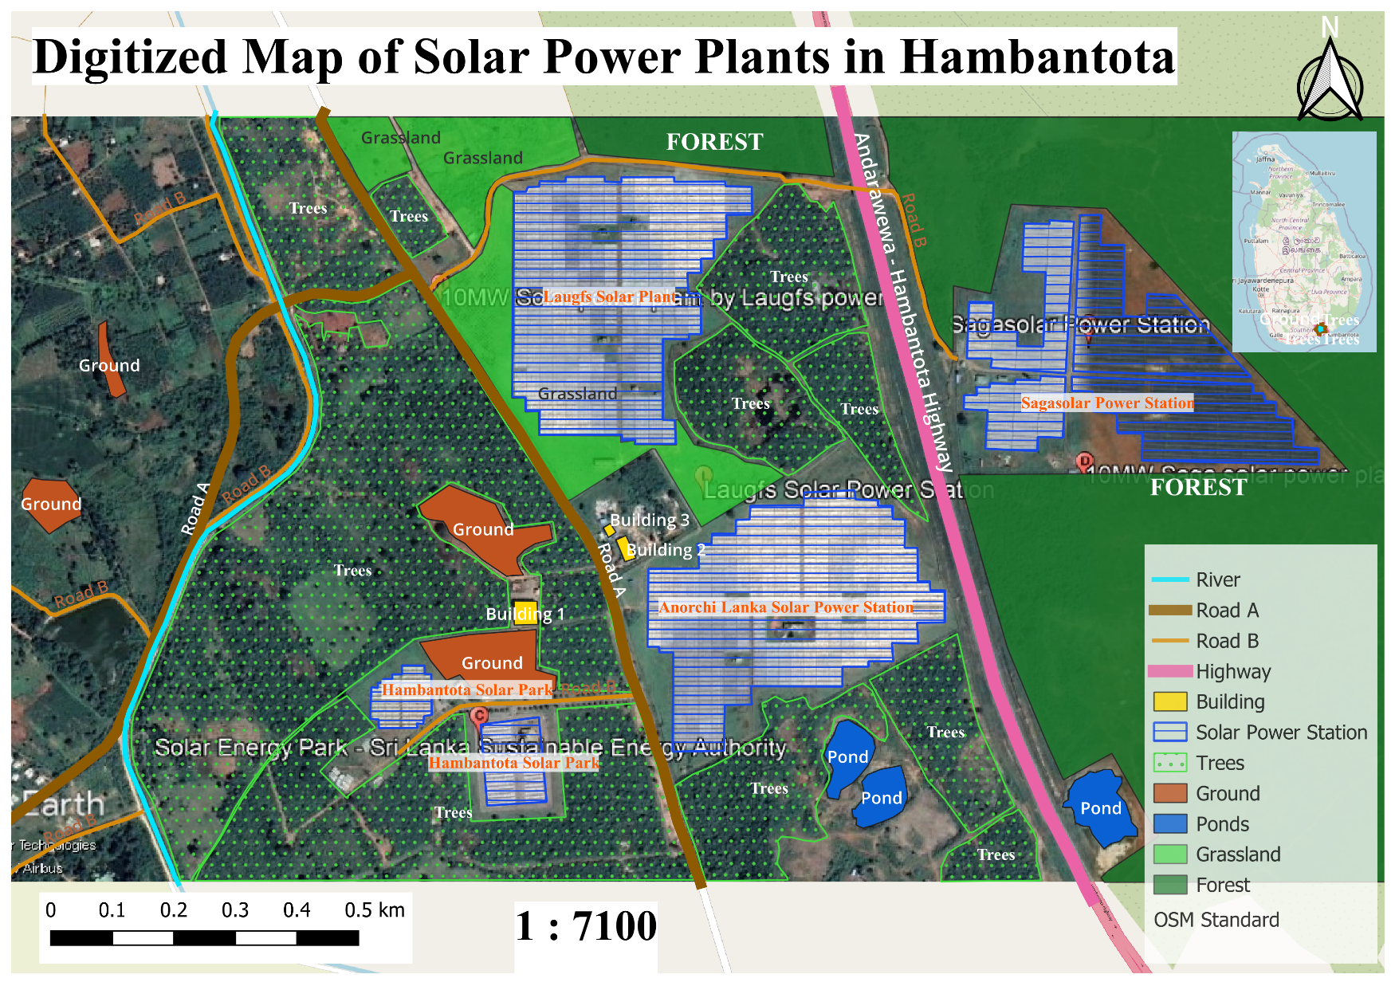

Figure 5.1Digitized Map of Solar Power Plants in Hambantota

Sri Lanka is a country that receives sunlight throughout the year. That is, solar power is a sustainable option for a country. Therefore, it is possible to overcome the problems in the energy sector without any doubt. As shown in the above map, there is a large amount of unused land in Hambantota and Wellawaya areas. Moreover, the infrastructure needed to build a new solar power plant is also available in this area. Below is a review of how well solar energy contributes to overcoming the problems in the energy sector.

Energy sources should be diversified. At present, fossil fuels are mostly used to generate electricity. That is, energy generation is heavily dependent on fossil fuels. The price of fossil fuel in the market varies from day to day. Moreover, due to other economic and political reasons, energy security issues arise. Therefore, the energy sources used in the production of electricity should be diversified. A perfect example of this is solar energy.

Facilitating rural electrification. There are many areas in Sri Lanka that are far from normal infrastructure. There are many cases where it is very difficult or expensive to provide electricity to such areas. In such cases, as shown in the map above, solar power plants can be easily generated by building solar power plants on unused vacant land in rural areas with good sunlight.

Increased reliability and stability of the network. During periods of drought, the process of generating hydroelectricity stops. During such times, power cannot be provided stably if there is excessive demand. That is, the stability of the grid breaks. In such cases, if there is a solar power plant, it can be matched with the high demand.

# 

**QUESTION F**

First a PostgreSQL geospatial database is created by entering the provided data. Here, monthly petrol and diesel consumption statistics across districts have been included using data from Sri Lanka Sunitya Energy Authority report. This report has the following topics. They are District Name, Number of Sheds, Petrol Mean and SD, Mean and Diesel SD. Using this data, the distribution of sheds per district is displayed on a map. Below is a screenshot of the afore-mentioned data set.

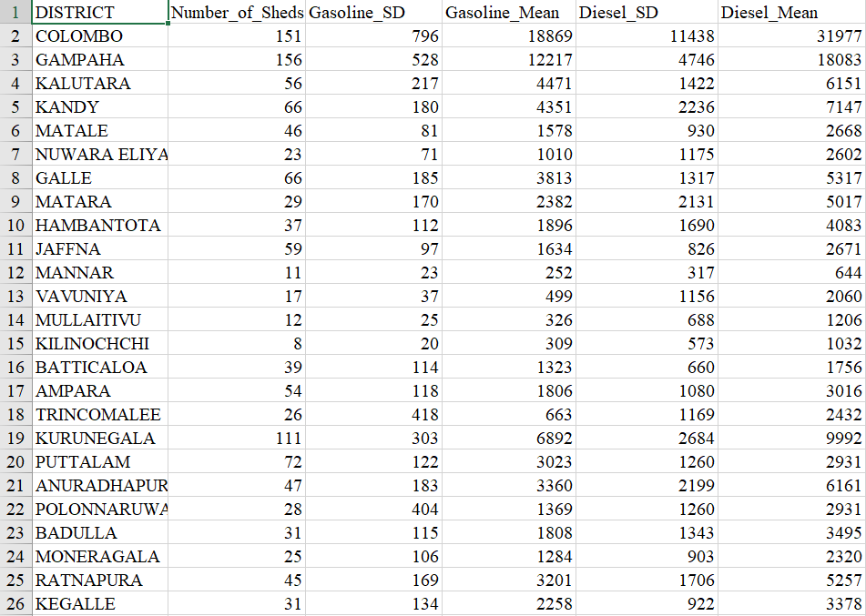

Figure 6.1Number of sheds, Gasoline, and diesel dataset

Below is a thematic map with number of sheds, mean and SD of petrol, mean and SD of diesel for each district using the data set mentioned above.

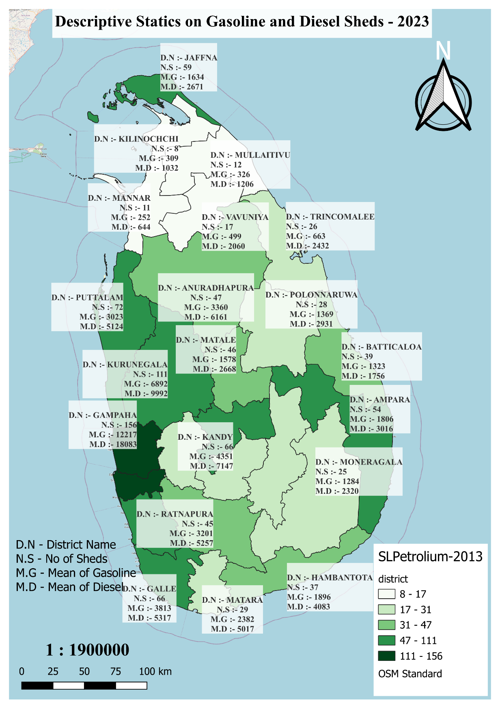

Figure 6.2Descriptive Statics on Gasoline and Diesel Sheds - 2023

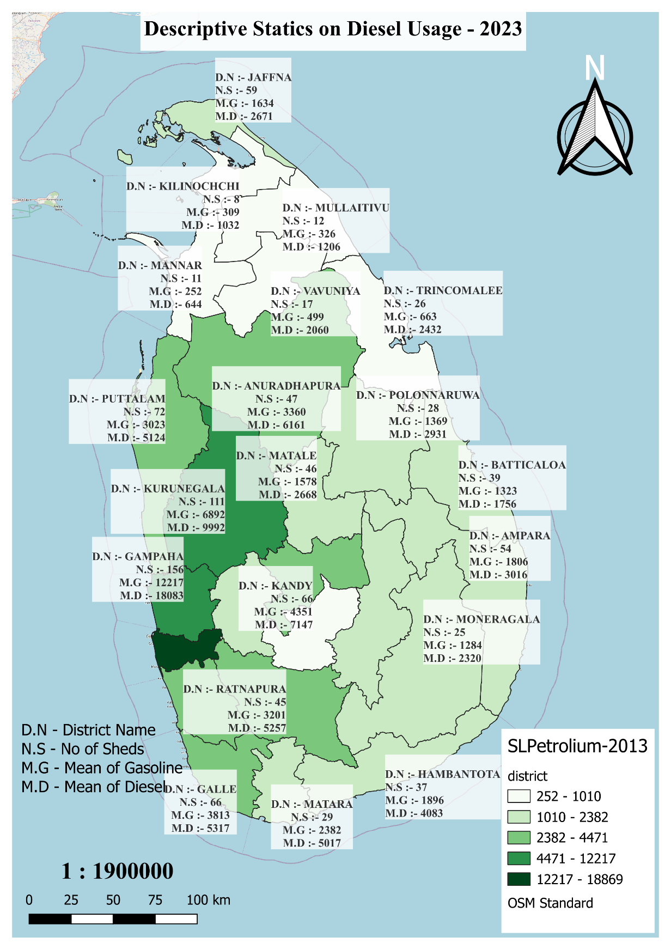

Figure 6.3Descriptive Statics on Diesel Usage - 2023

The thematic map shown above displays the number of sheds, mean of petrol and mean of diesel for the districts of Sri Lanka. According to the above map, Gampaha district can be considered as the district with the highest number of sheds in Sri Lanka. The mean value of petrol and diesel consumption in this district is 12217 and 18083 respectively. There are 156 sheds in Gampaha district. But there are only 151 sheds in Colombo district. However, Colombo is the district that consumes the most petrol and diesel in Sri Lanka. It means that a large number of vehicles pass through this district. The construction of new sheds in Colombo district will benefit both the government and the consumer. Thus, the customer can easily get fuel without standing in a queue.

Kurunegala district has the third largest number of sheds in Sri Lanka. In terms of petrol consumption, the third highest petrol consumption in Sri Lanka is in this district. The mean value of petrol and diesel consumption in this district is 6892 and 9992 respectively. Kilinochchi district has the lowest number of sheds in Sri Lanka. That value is 8. However, compared to the districts mentioned above, the use of petrol and diesel is less in the northern area. As the consumption is reduced, it does not matter if the number of sheds is reduced.

# 

**QUESTION G**

Due to environmental and economic advantages and its importance, all the nations of the world are turning towards renewable energy types in meeting their energy needs. Sri Lanka is a tropical country located in the Indian Ocean and its administrators have focused on using renewable energy sources. SLSEA has identified potential sites for renewable energy generation in Sri Lanka(Rodrigo, n.d.). This chapter deals with the marking of suitable locations on the map for the construction of power plants in the fields of solar, wind and biomass. The suitable locations for construction of power plants are selected and the correct latitude and longitude of the location is obtained by Google Earth Pro, KMZ files are created and the map is created using QGIS. The following map shows the most suitable locations in Sri Lanka for the construction of the above-mentioned power plants.

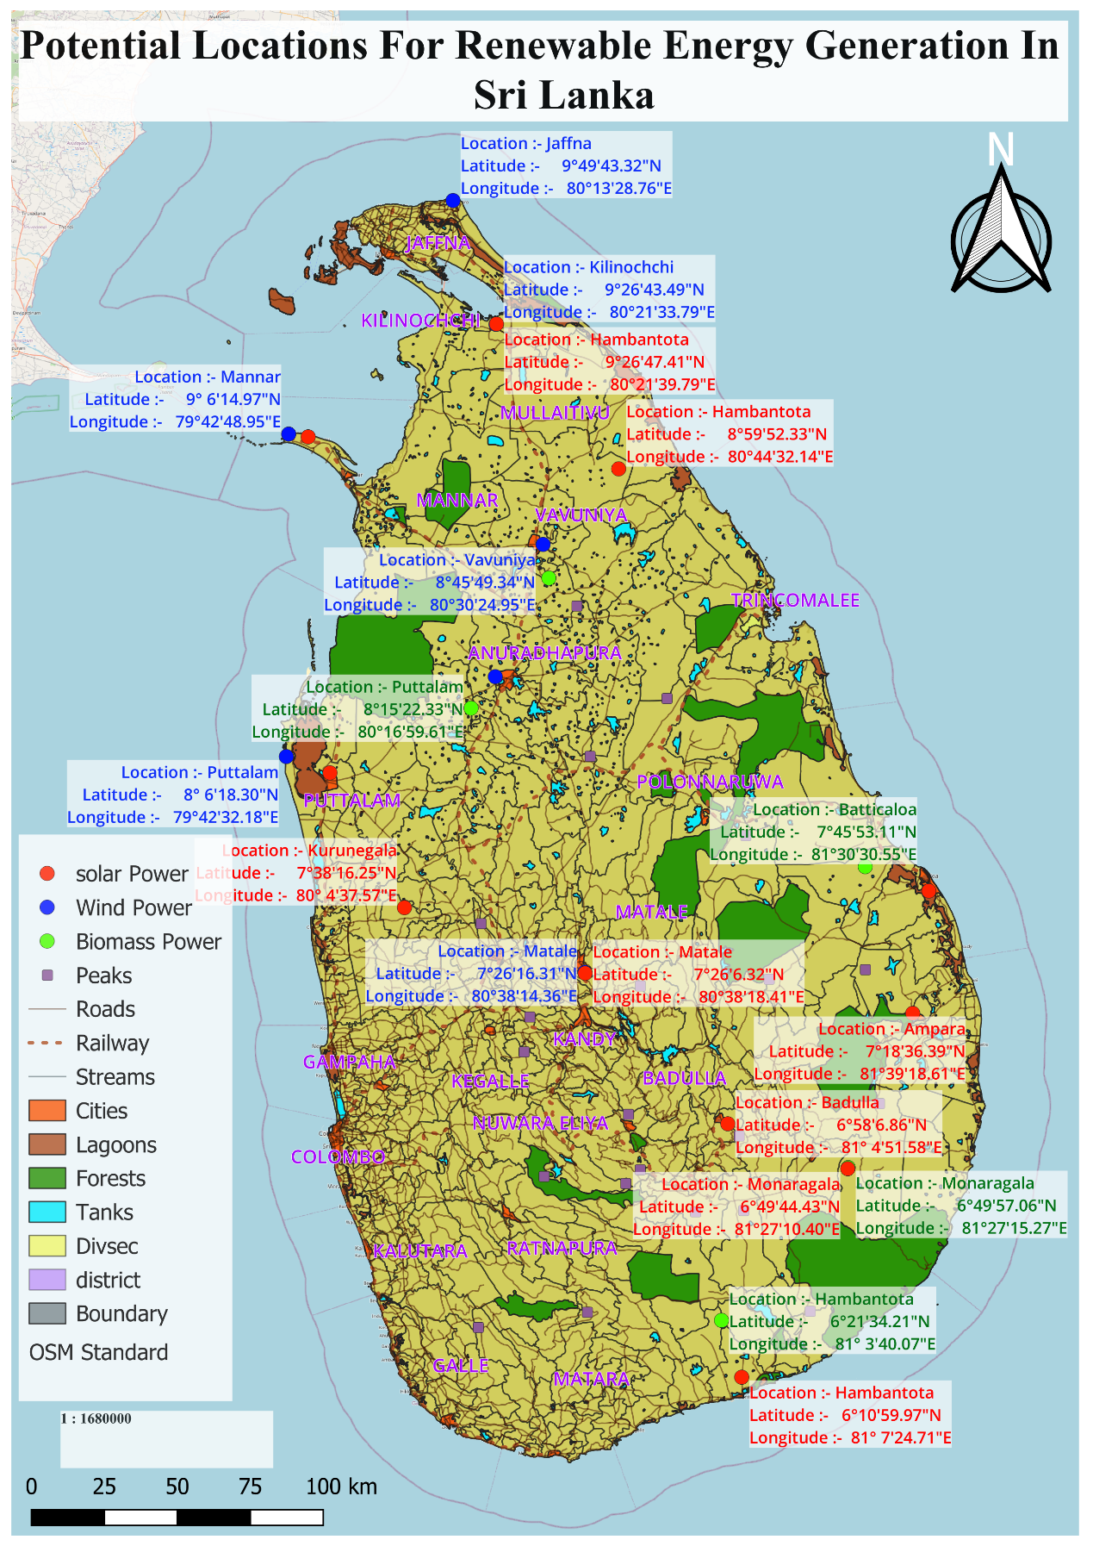

Figure 7.1Potential Locations For Renewable Energy Generation In Sri Lanka

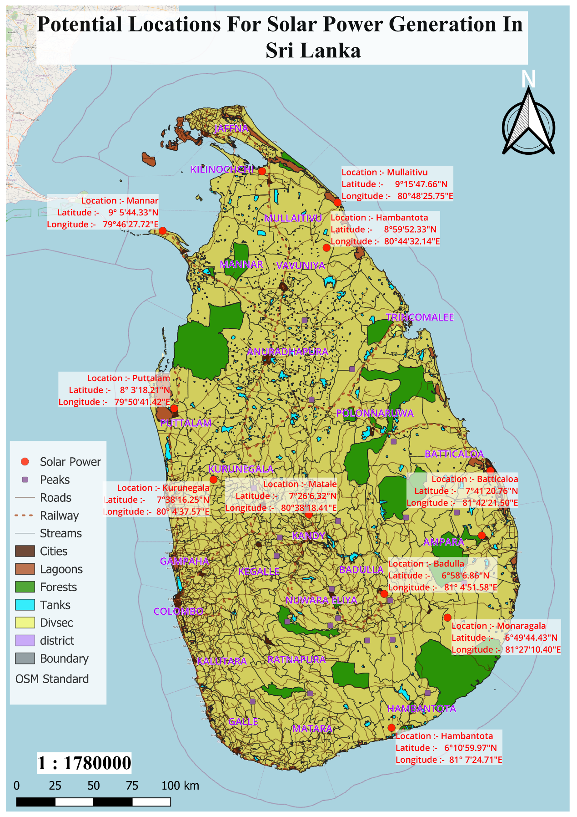

Figure 7.2Potential Locations for Solar Power Generation In Sri Lanka

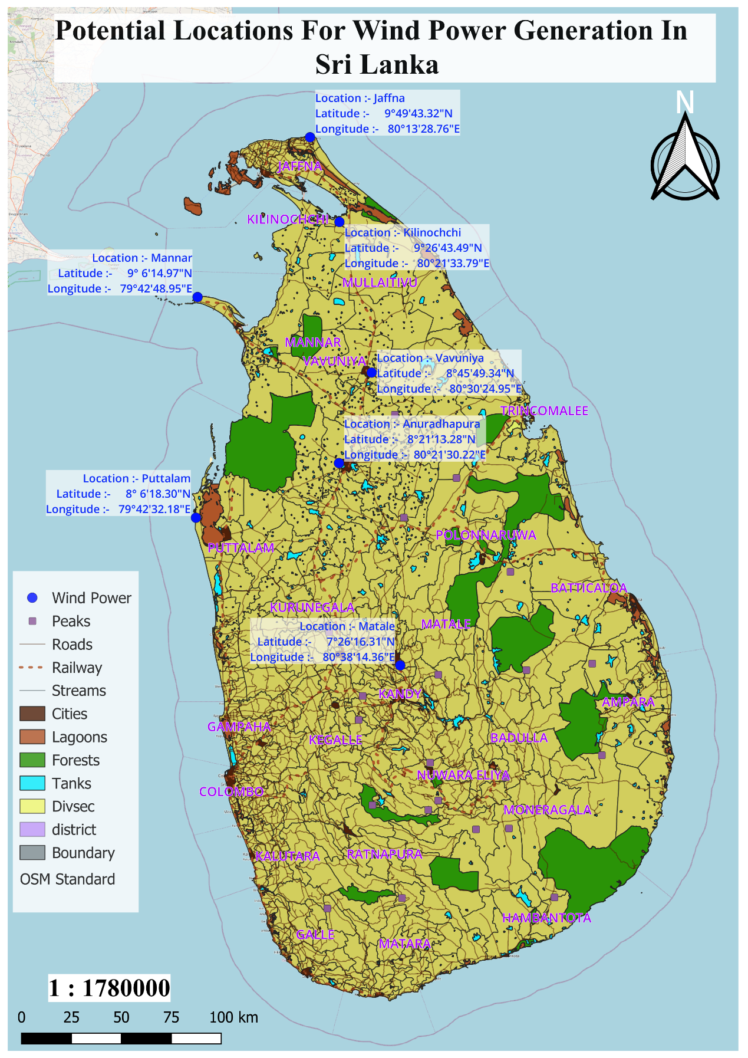

Figure 7.3Potential Locations for Wind Power Generation In Sri Lanka

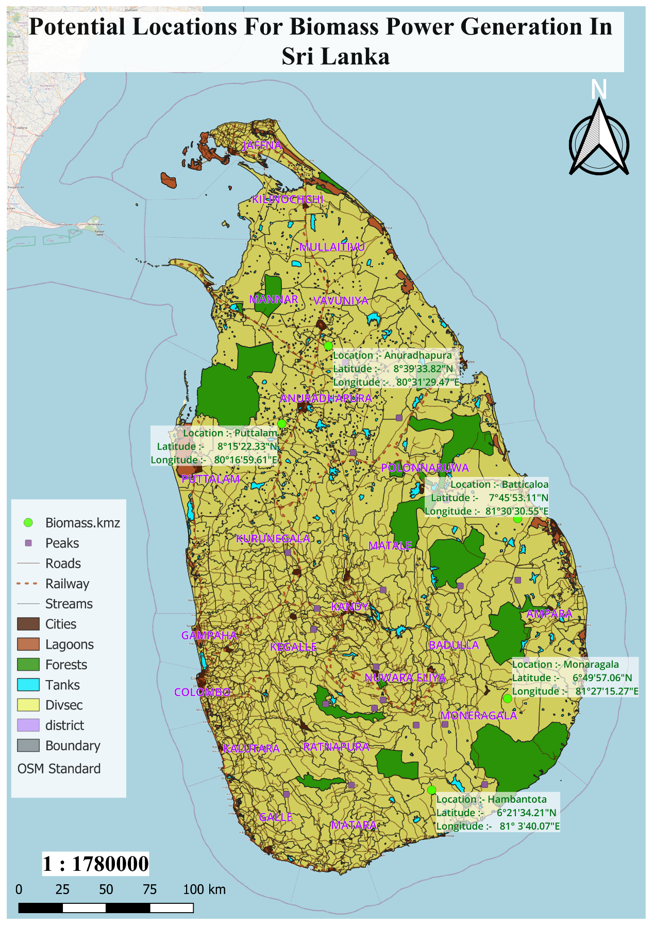

Figure 7.4Potential Locations for Biomass Power Generation in Sri Lanka

In the above map, the 3 types of power plants are marked with three colors. Red indicates solar power plants and blue indicates wind power plants. Biomass plant is shown in green. Forests, rivers, reservoirs are also included in the map.

There are many points to be aware of while scoring the above positions. First, research should be done in finding suitable locations for solar power plants. According to the data provided by Sri Lanka Solar Energy Authority, they have specified many possible locations and we have selected the most suitable locations among them. The locations suitable for setting up solar power plants in the selected districts are marked in red. 12 districts like Ampara, Mullaitivu, Mannar, Kurunegala, Batticaloa, Badulla etc. have been selected to build solar power plants. The latitude and longitude of the selected location in that respective district is visualized on the map.

7 locations in 7 districts have been selected for the construction of wind power plants. They are Anuradhapura, Jaffna, Kilinochchi, Mannar, Matale, Puttalam and Vavuniya. While marking these places, schools, hospitals and homes were chosen. As mentioned in the above section, the latitude and longitude are also shown in these places.

For the construction of biomass power plants in the districts of Hambantota, Monaragala, Anuradhapura, Batticaloa and Puttalam, the green areas are marked.

According to the above map, the power authority can start the construction of power plants very easily.

# 

**QUESTION H**

In this chapter, a map is created to find a suitable land in Kandy to build a regional research center on renewable energy. Three areas of vegetation are used to find the most suitable land. They are Industrial Development Centre, Uruvala Primary School and Jayathilaka Hall. This land should be sought from a certain distance to these places (500 meters from Uruvala Primary School, 600 meters from Industrial Development and 700 meters from Jayathilaka Hall).

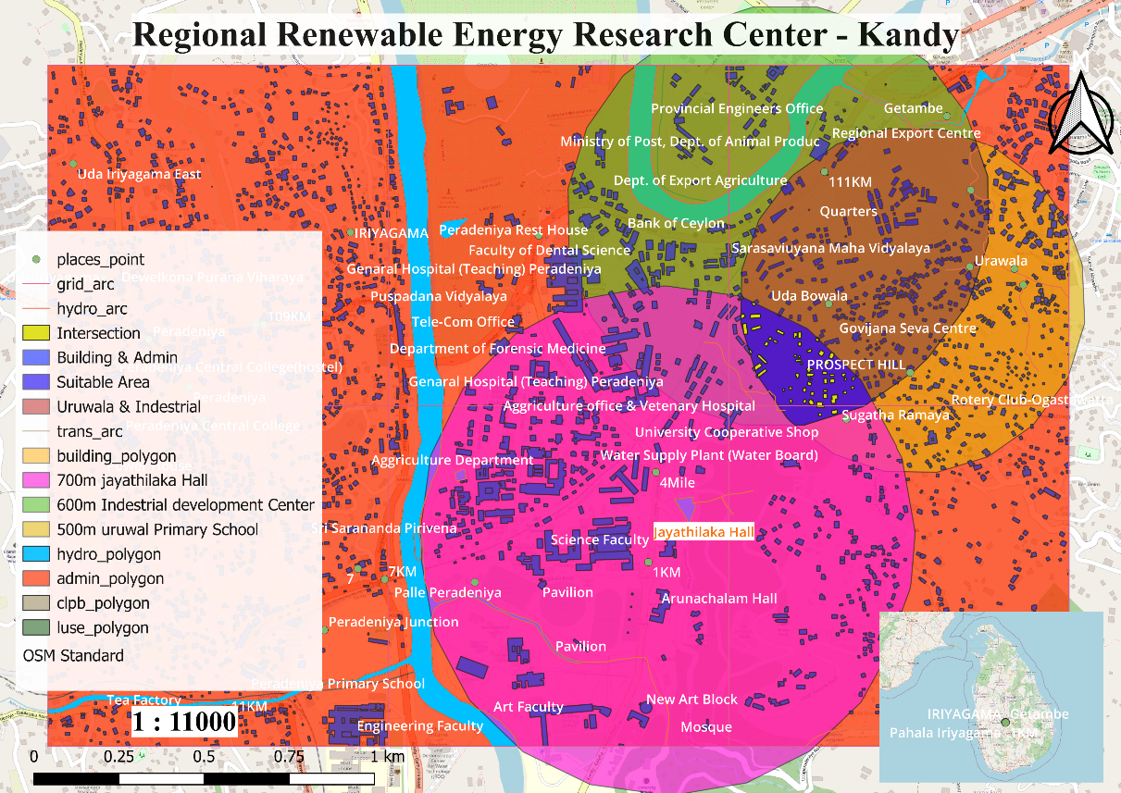

Figure 8.1Regional Renewable Energy Research Centre - Kandy

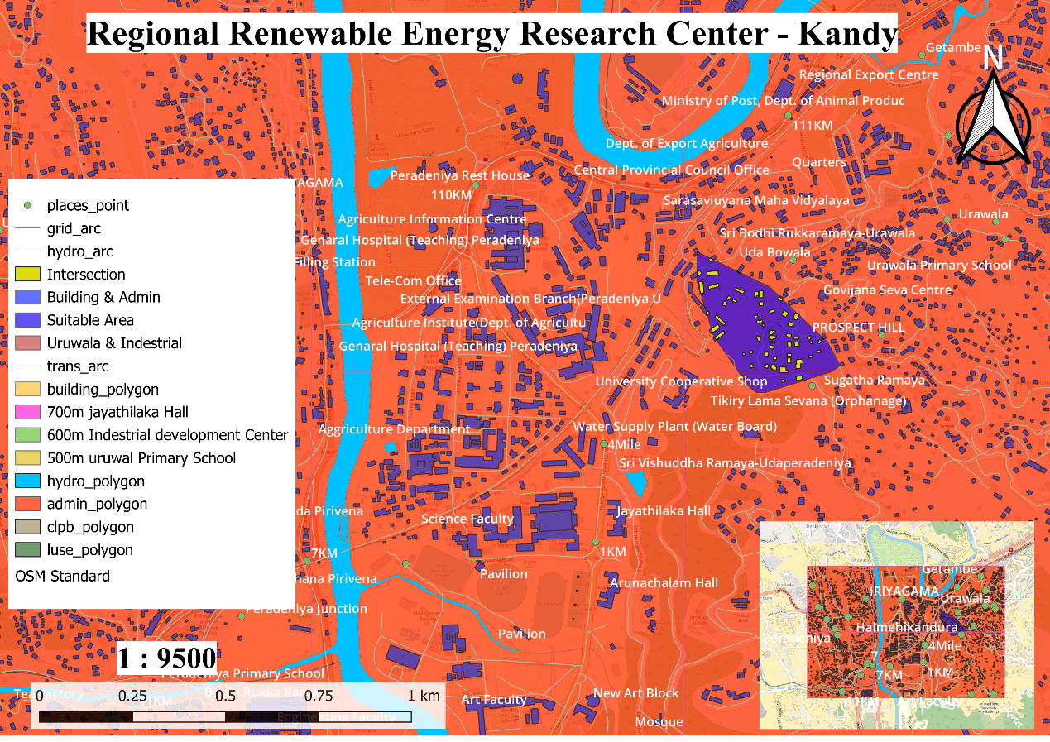

Figure 8.2Regional Renewable Energy Research Centre - Kandy

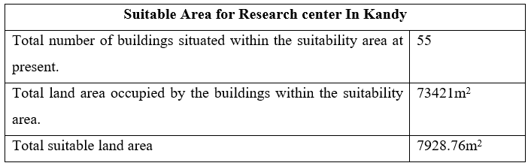

Table 8.1Suitable Area for Research centre In Kandy

Stations are used to carry out the various station planning process as mentioned in the figure above. Accordingly, 03 locations have been used for planning the intersection, Uruwela Primary School, Industrial Development Center and Jayathilaka Hall. As indicated by each color, the yellow circle on the map is five hundred meters from Uruwela Vidyalaya, the green circle is 600 meters from the Task Development Center and the pink is 700 meters from Jayathilaka Hall. The best area for fishing is shown in blue. It should be said that the Agricultural Service Center is located around the selected area. Also, Sugatharamaya is located on the right. There are 55 buildings in the area reserved for the above-mentioned regional research centers.

Finally, the regional research center created for this renewable energy will provide several opportunities such as regional innovation, educational development and sustainable development.

55 buildings were identified in the allotted area to find suitable land for the construction of the Regional Research Centre. The total area of this entire area is 73421m2. But the area of land suitable for building the building in this area is about 7928.76m2.

# CONCLUSION

In the first and second tasks, accurate statistical models were created based on the structural factors and cooling factors of a building using the R programming language and the aforementioned data set and data analysis were performed. At the end of this analysis, the relationships between cooling systems, building structures and energy consumption were identified. They are described separately.

In the third task, using the dataset "SLWindPowerLand_21_23.csv", a visual representation of the feasible land for the construction of new wind farms in Sri Lanka has been made. Here the viable land available in each district is shown on the map.

In the fourth task, a classified map is created based on the estimated total energy generation of the land district suitable for the construction of solar power plants using the given data as done in the third task above.

In the fifth task, information about solar power plants and buildings on the Google Earth aerial image map was digitized using QGIS.

In the sixth task, a database was created in the PostgreSQL application using statistical data including monthly petrol and diesel consumption. A classification map was then created based on that data.

In the seventh task, suitable locations for renewable energy generation in Sri Lanka were identified using Google Earth and mapped using QGIS.

In the final task, a suitable land was selected for the construction of a regional research center in Kandy using QGIS and a map was created containing information about the area and the area.

# GANTT CHART

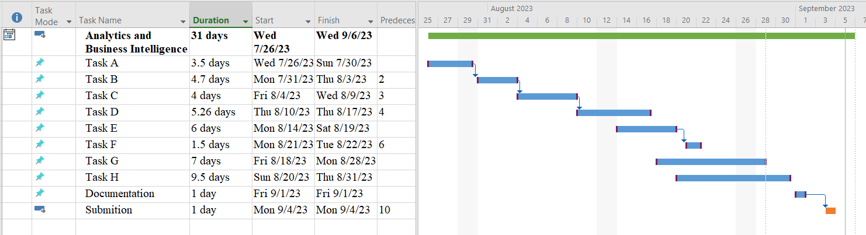

# 

# REFERENCES

PhD, S.M., 2022. Introduction to the Normal Distribution (Bell Curve) - Simply Psychology. Available at: <https://www.simplypsychology.org/normal-distribution.html, https://www.simplypsychology.org/normal-distribution.html> [Accessed 6 September 2023].

Rodrigo, D.A., n.d. Renewable Energy Resource Development Plan 2021-2026.

Sri Lanka Sustainable Energy Authority, 2023. *Wind Power*. [online] Available at: <https://www.energy.gov.lk/index.php/en/renewable-energy/technologies/wind-power> [Accessed 6 September 2023].

# APPENDIX

**Appendix C**

* Joined fields 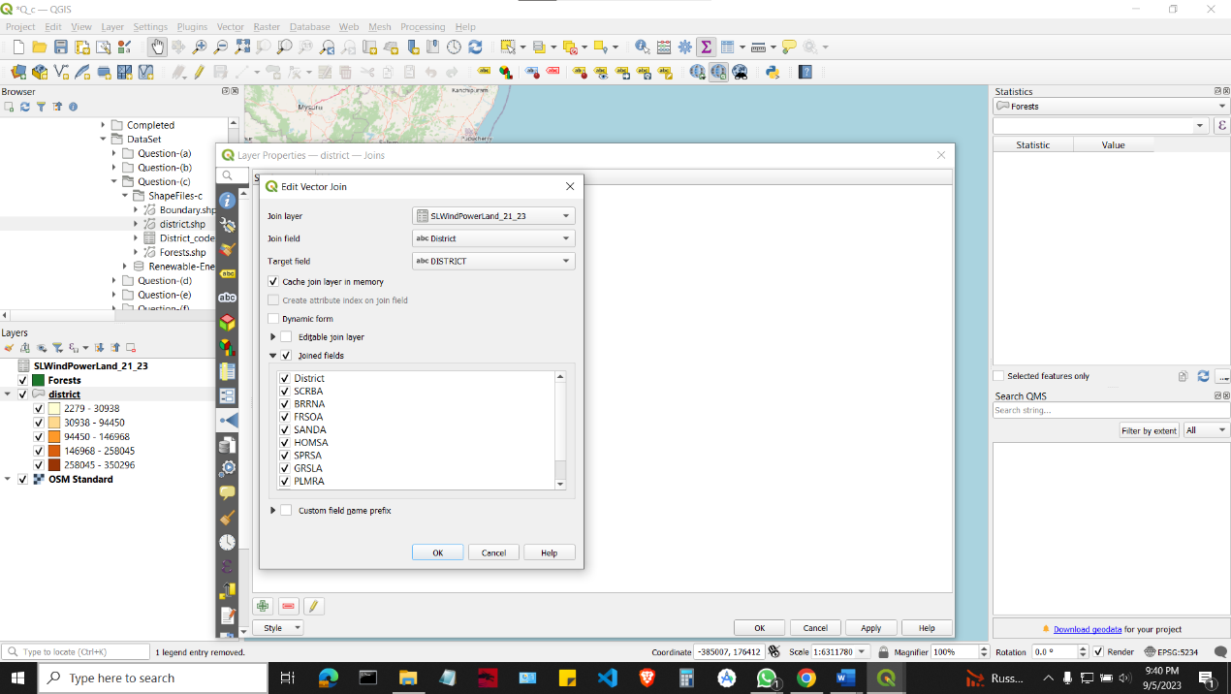
* Labeling map

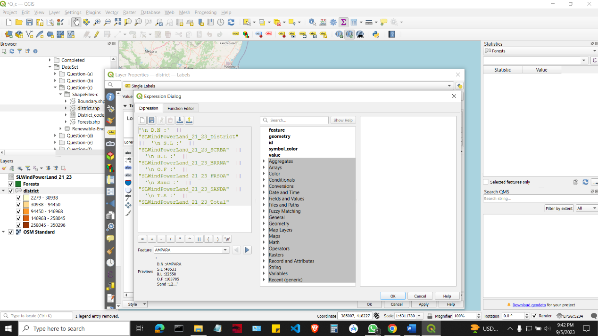

* 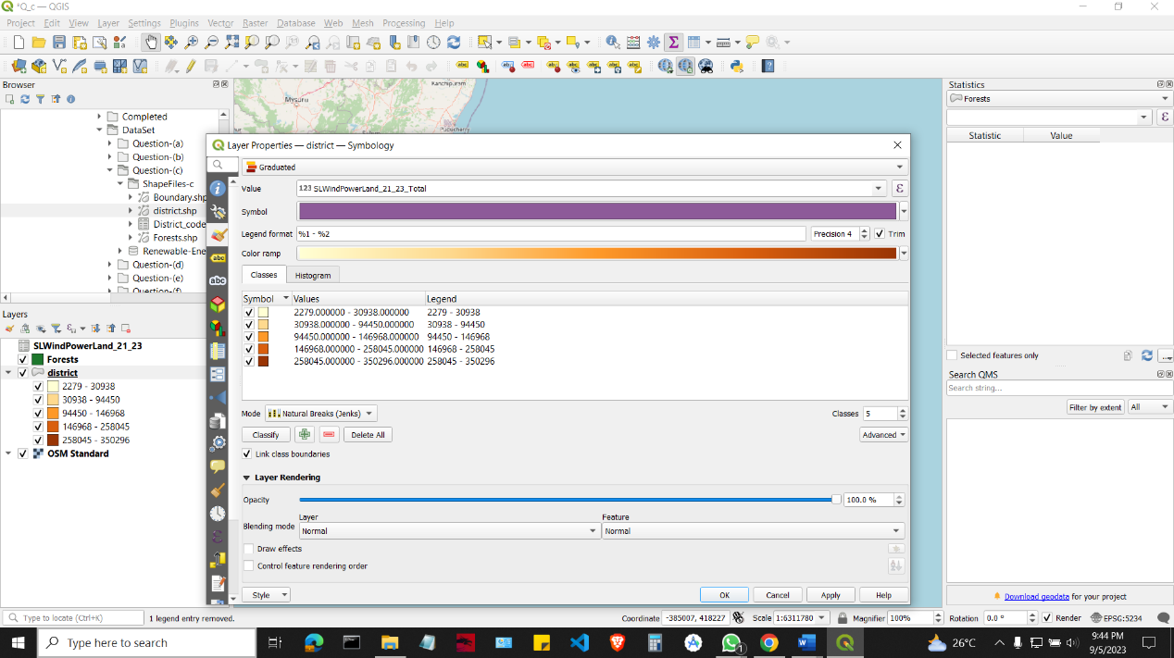 Visualize map using total area.
* Print View

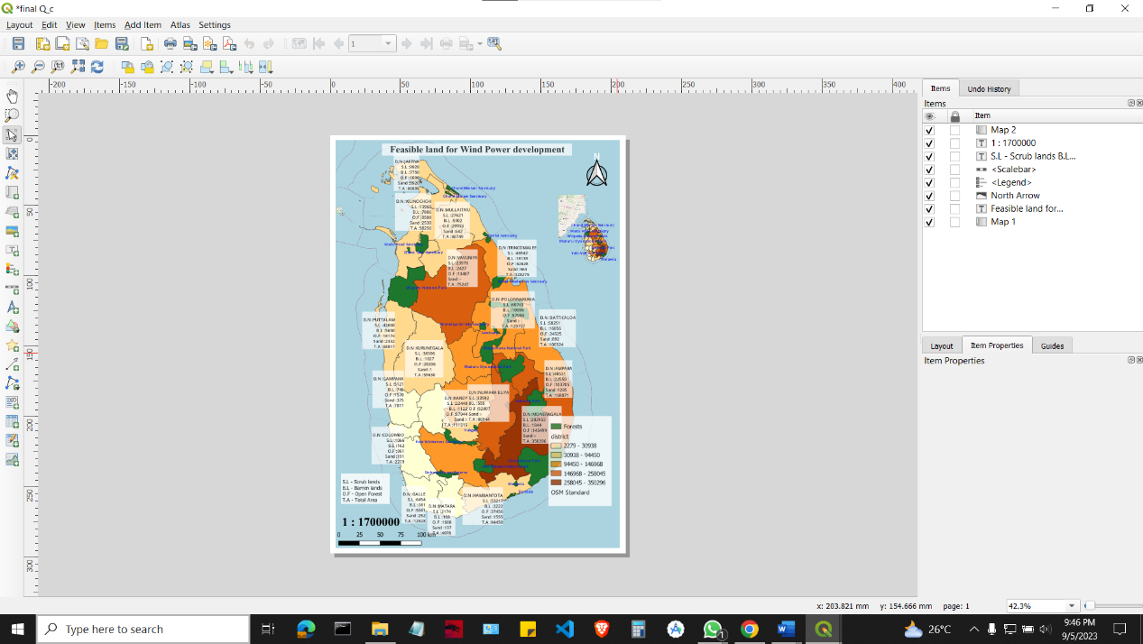

**Appendix D**

* **Select OSM Map**

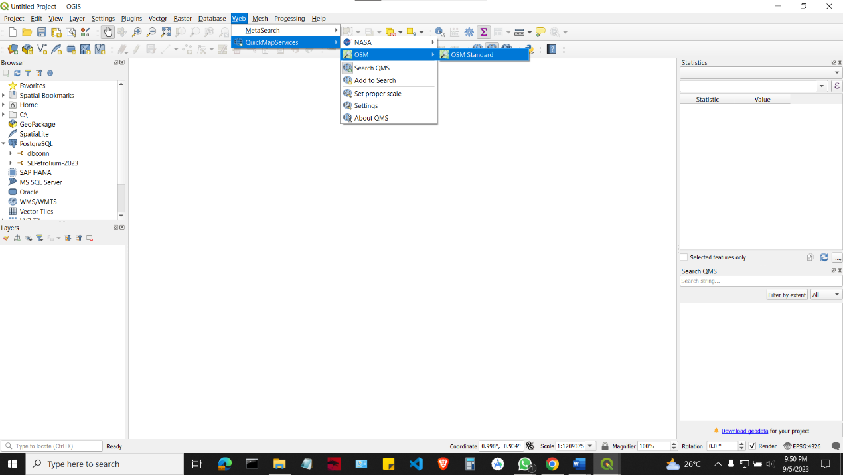

* Select Coordinate Reference System

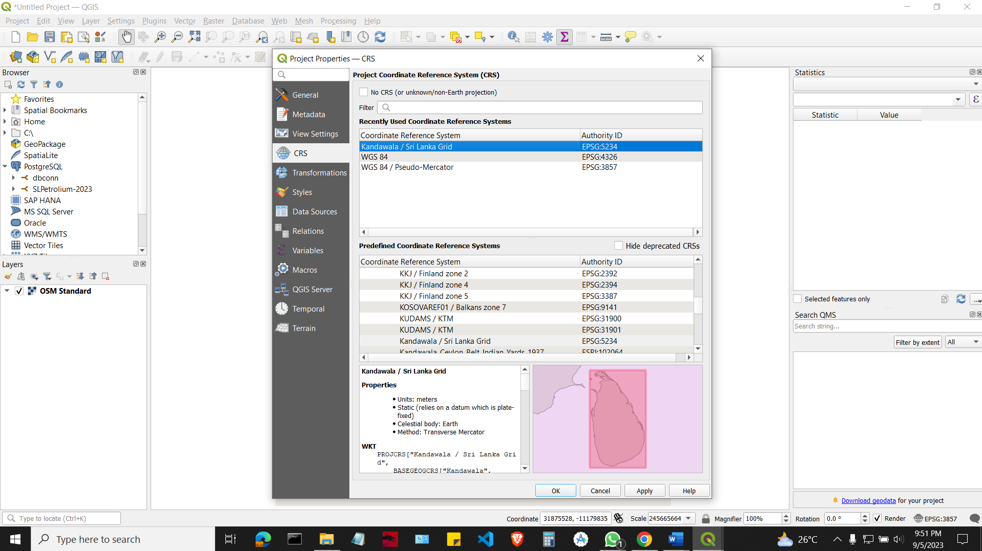

* 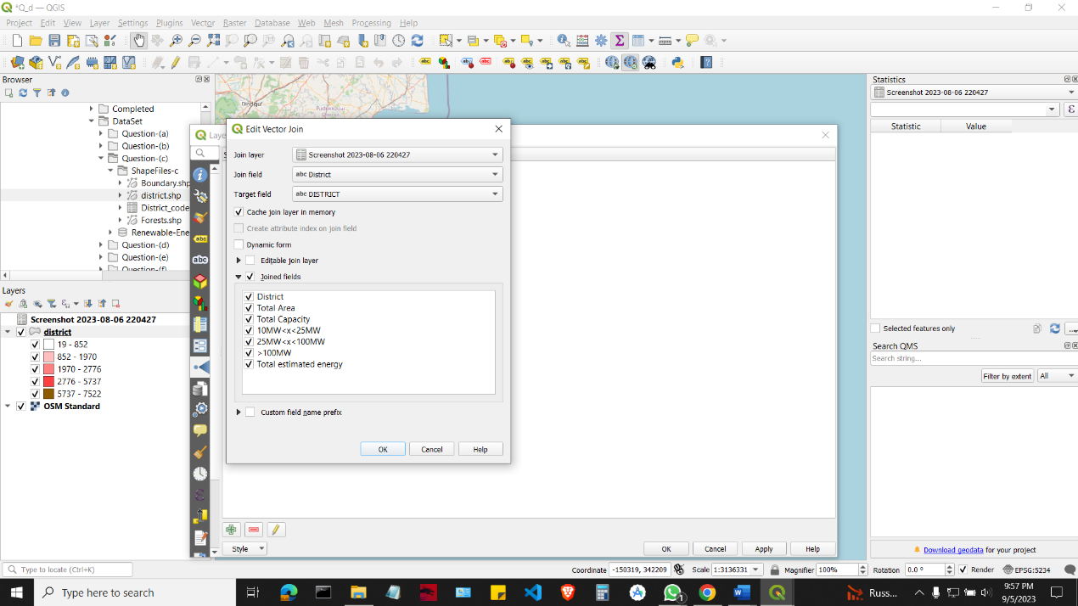Joined Fields

* After Jointed fields and layers

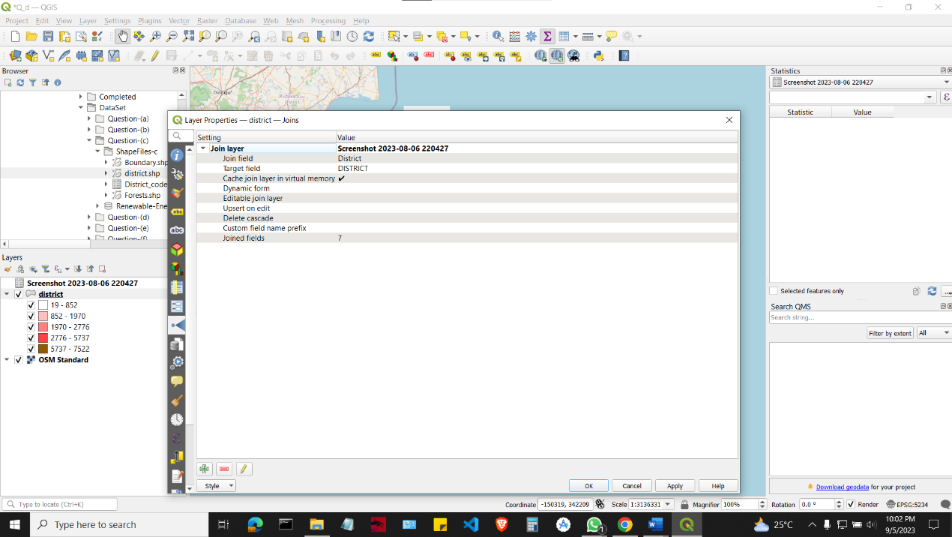

* 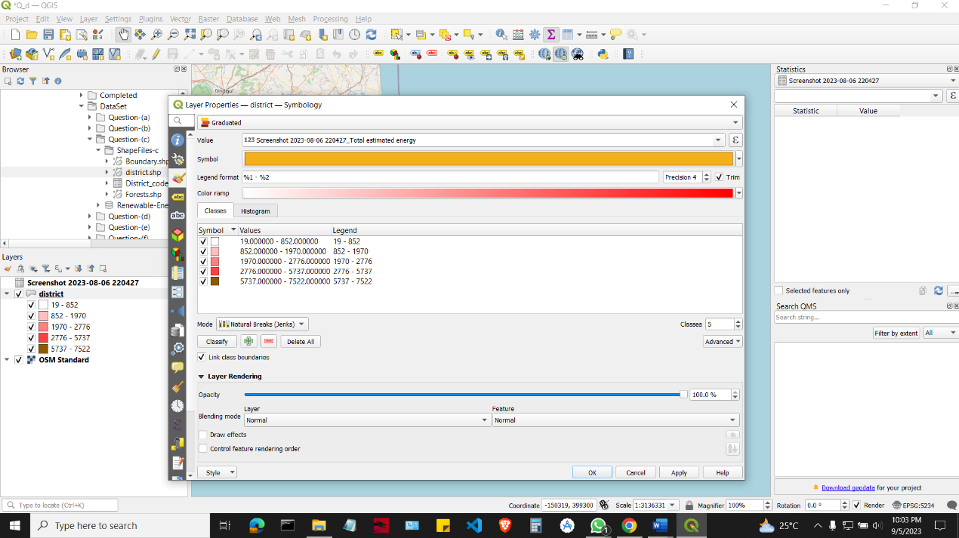Visualize map using total estimated energy.
* Map labeling

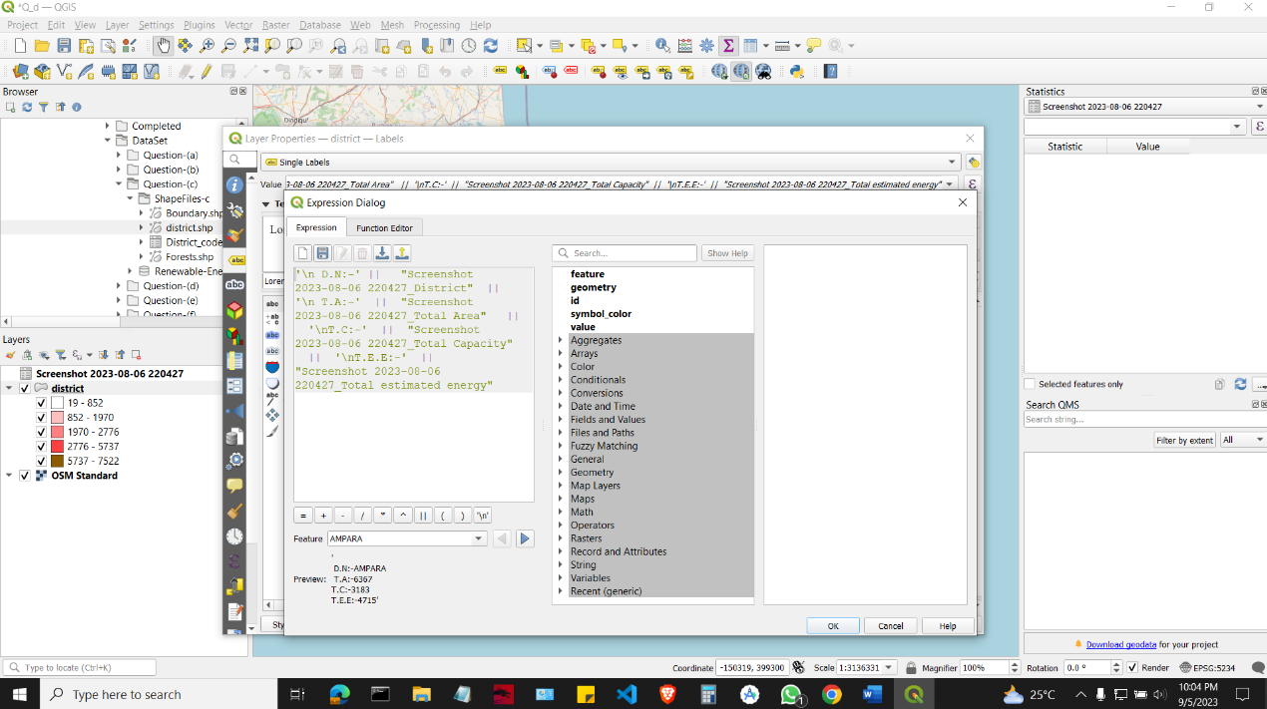

* 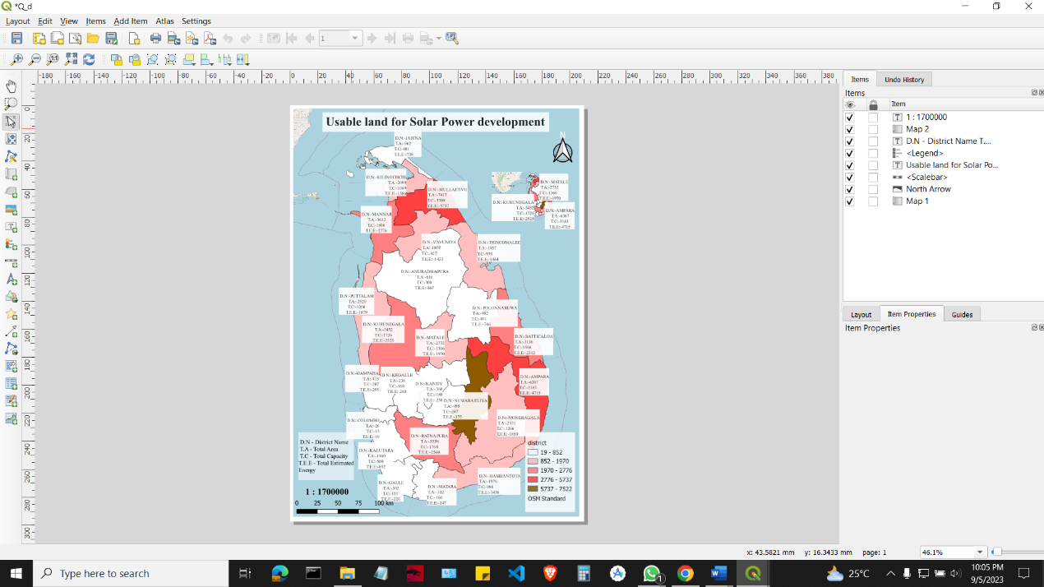Print View

**Appendix E**

* **Select OSM Map**



* Select Coordinate Reference System



* Pinned in Georeferenced

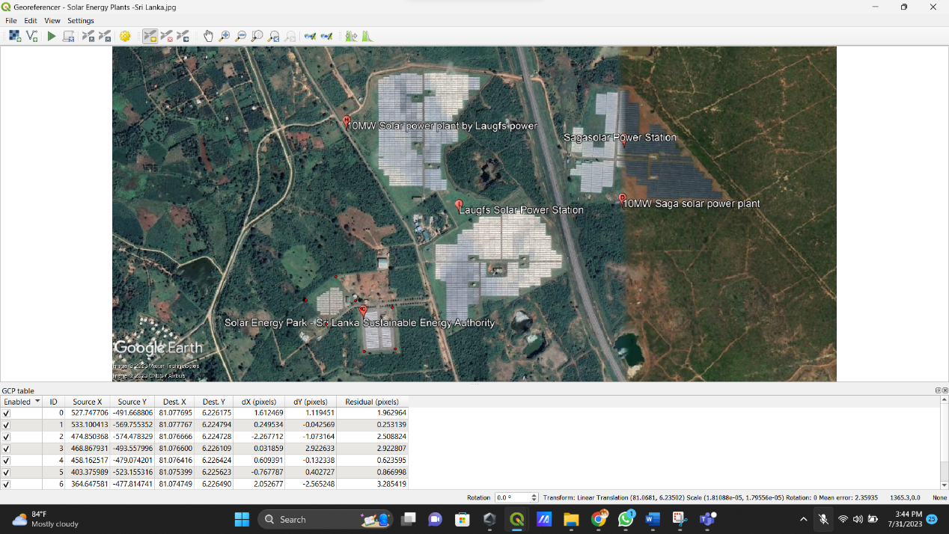

* Draw the map

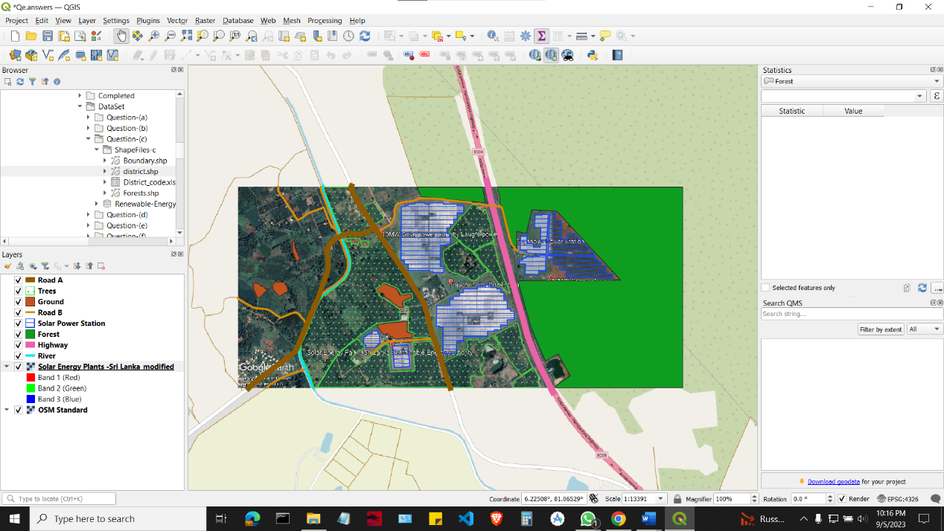

**Appendix F**

* 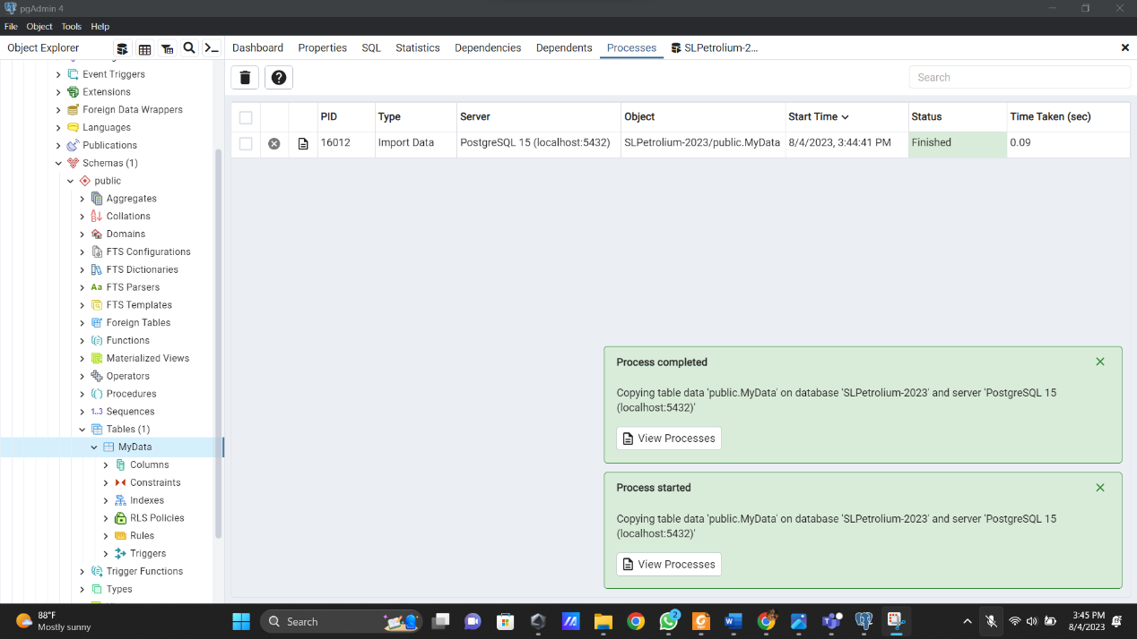Create a database and import the dataset into Postgresql
* After import dataset

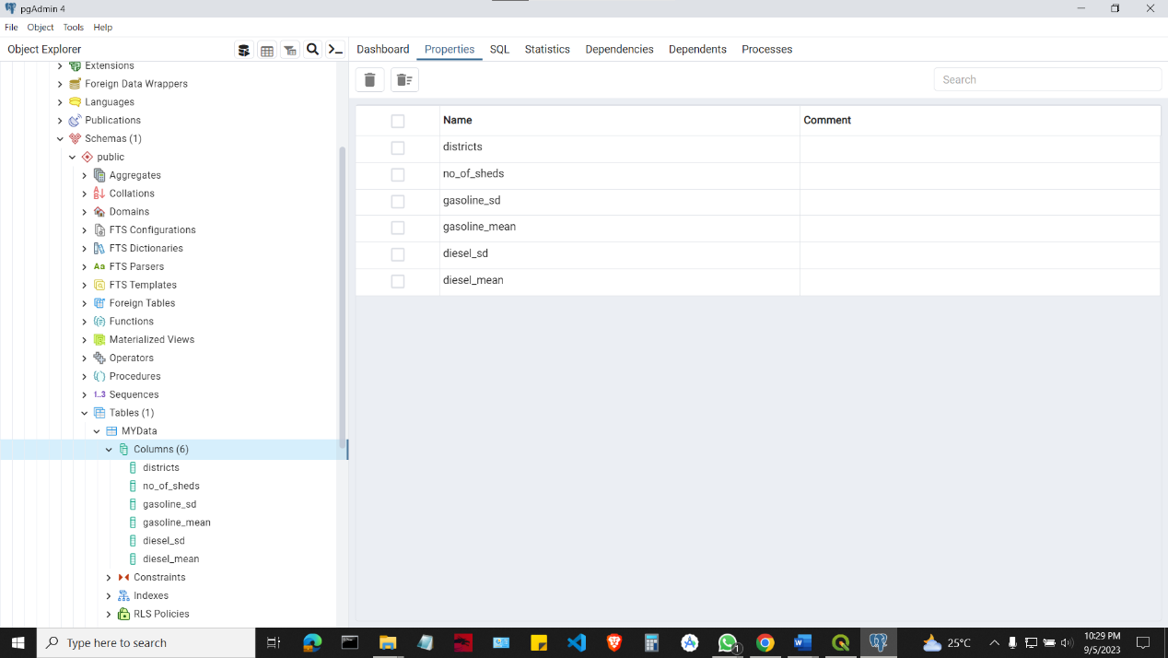

* 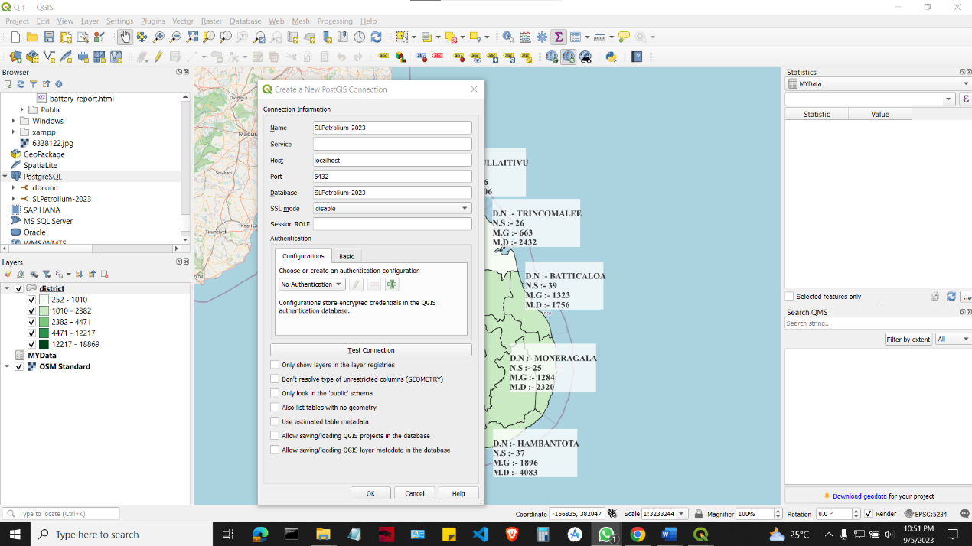Connect postgresql into QGIS
* Joined the field

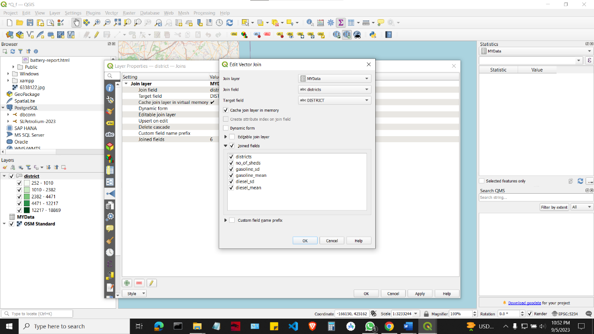

* 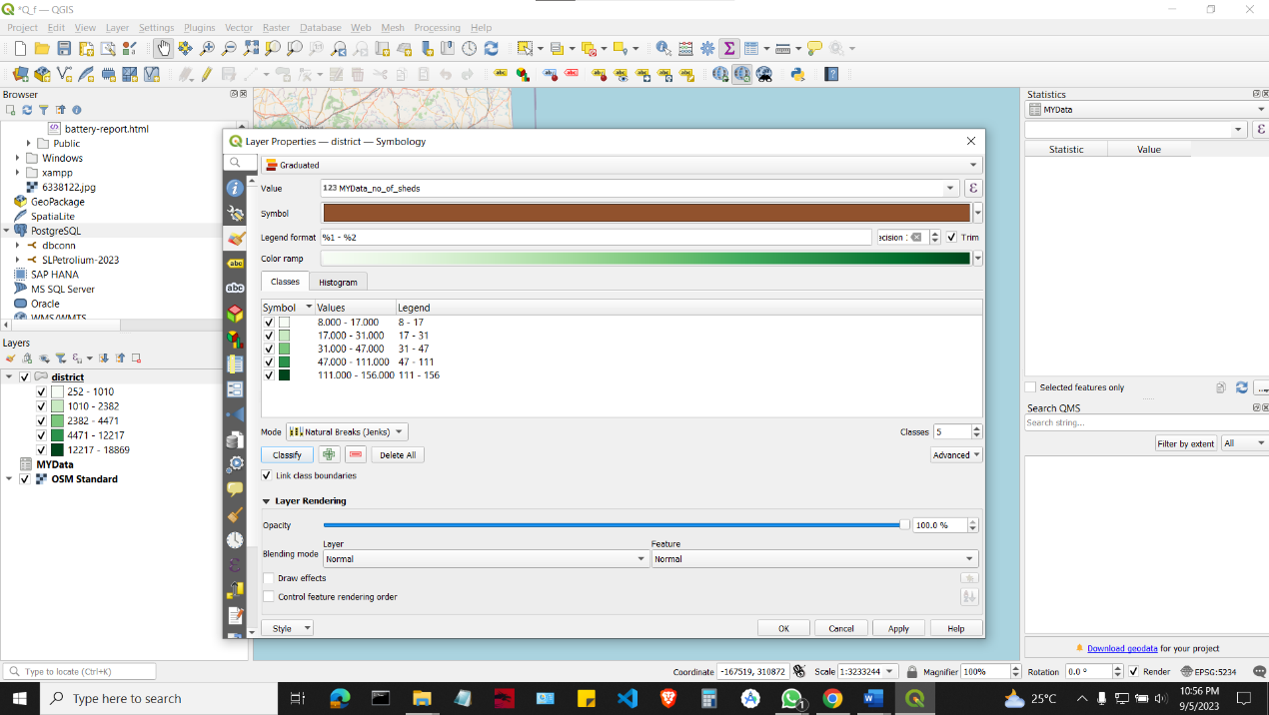Visualize map using no of shed
* 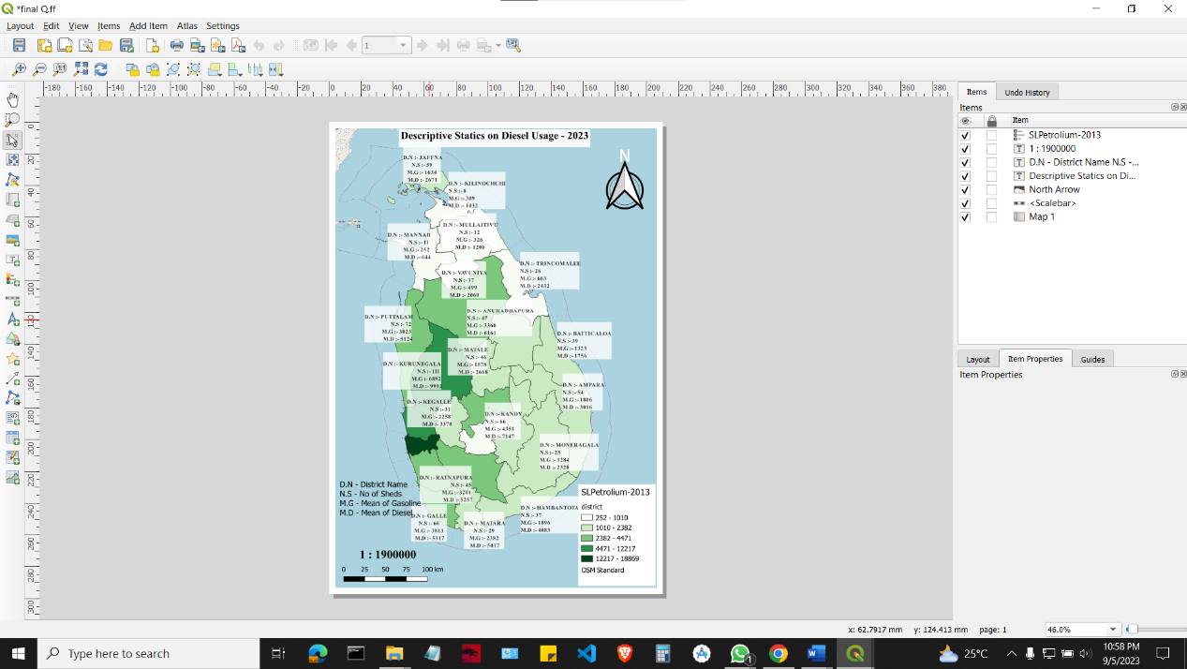Print View

**Appendix G**

* 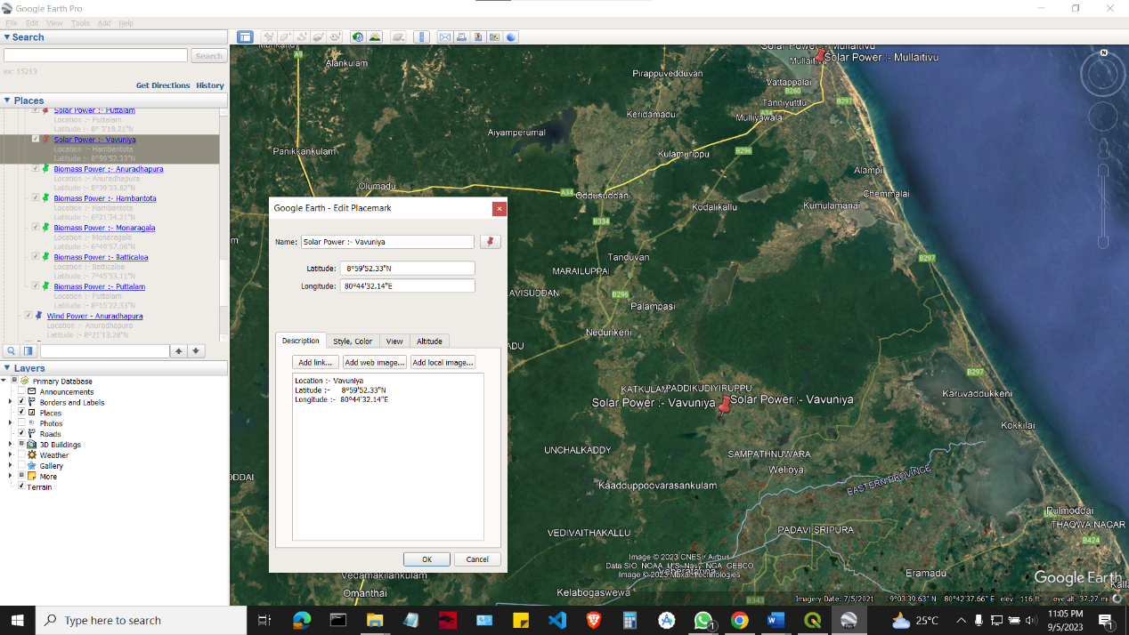Pined solar wind, solar, and Biomass places using Google Earth Pro
* Export KMZ File

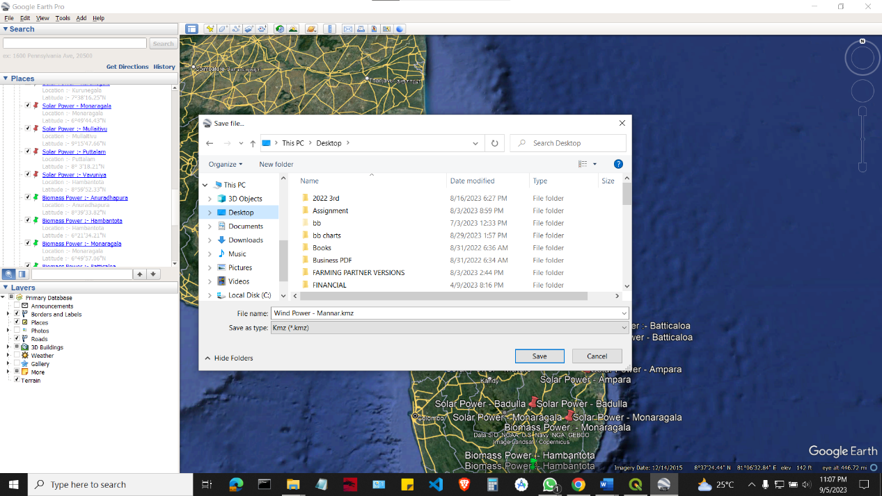

* 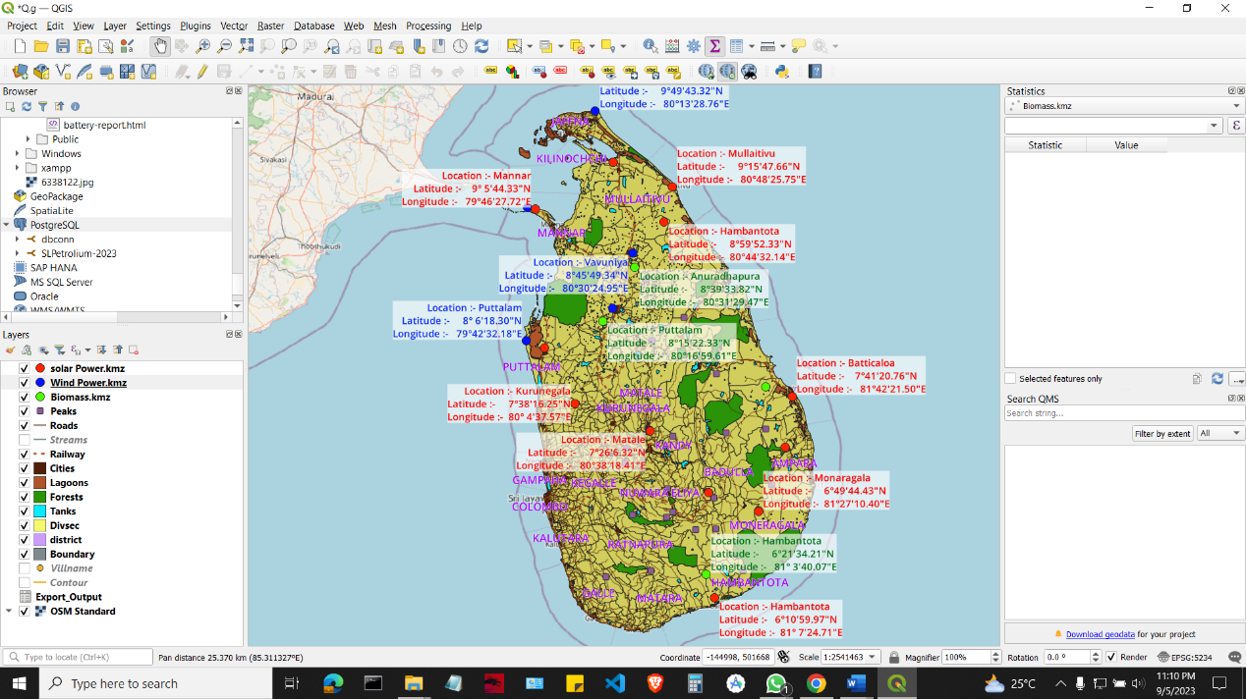Import KMZ File And label in to GQIS
* Print view

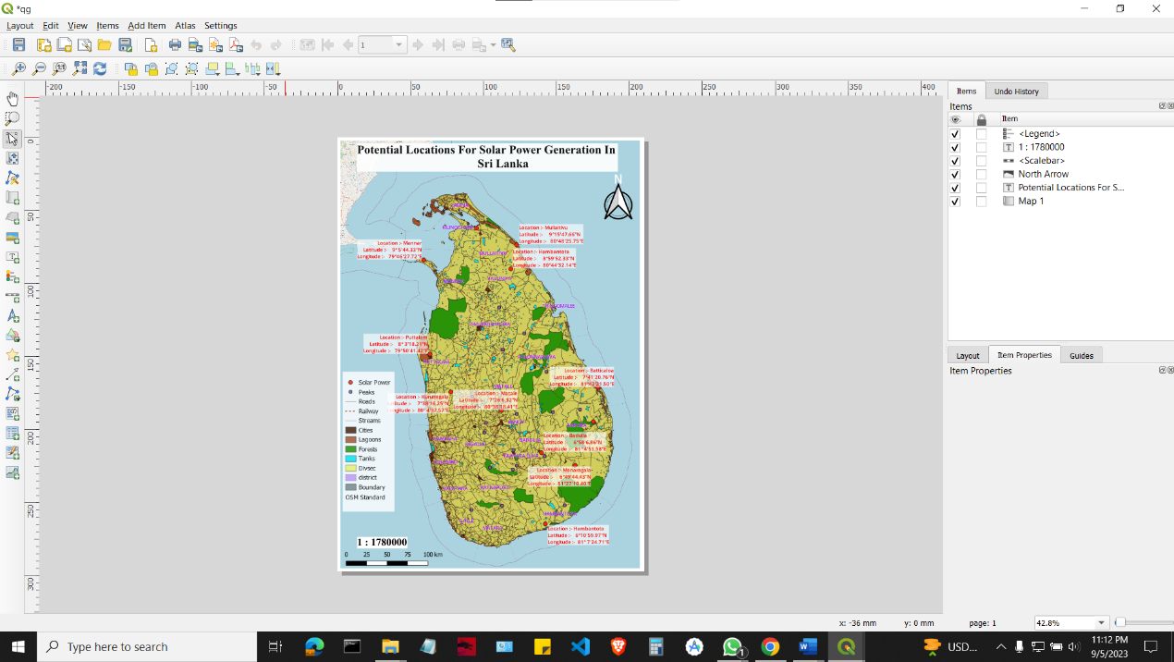

**Appendix H**

* **Select OSM Map**
* 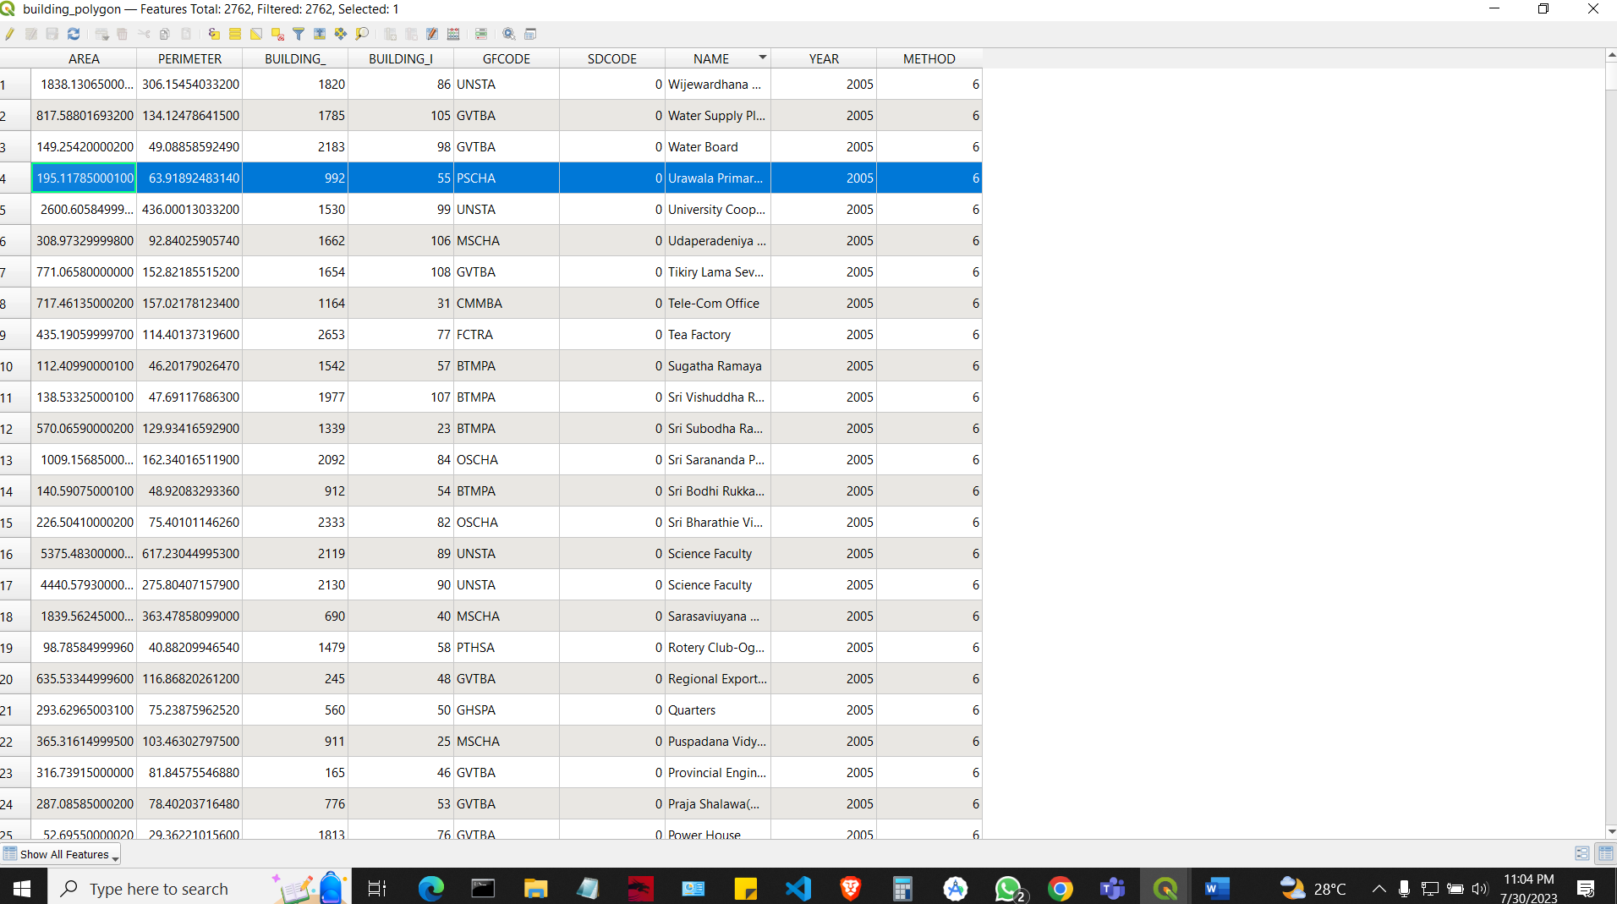**Find Uruwala Primary School**



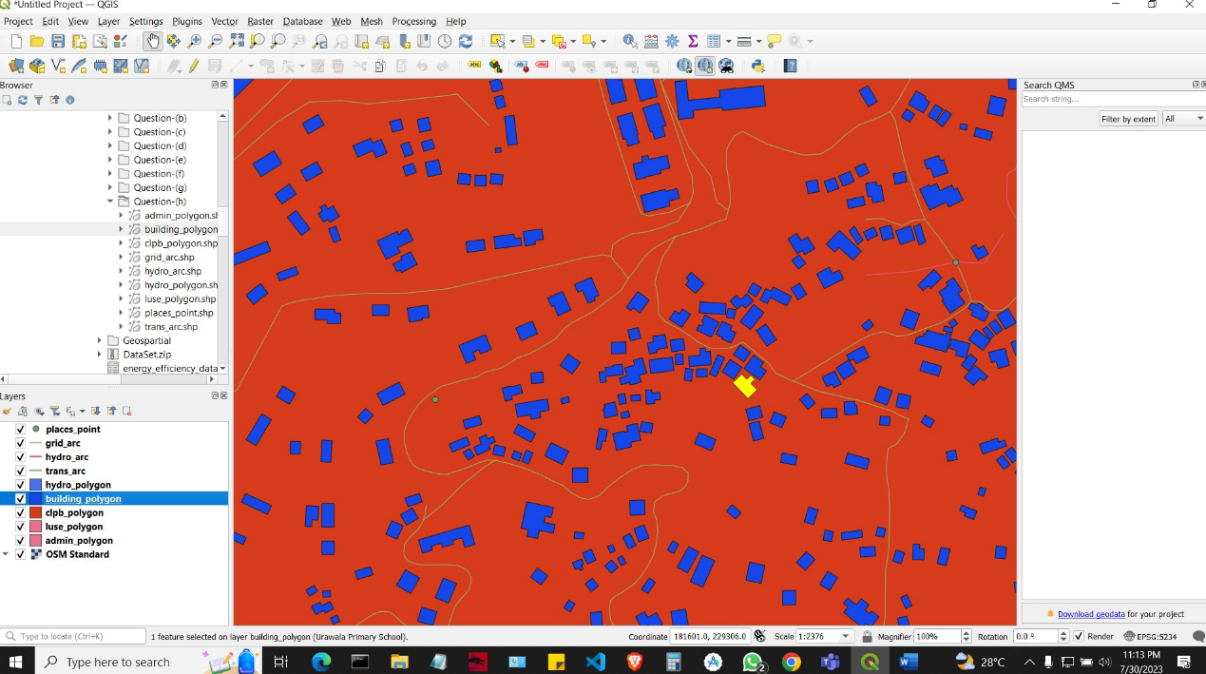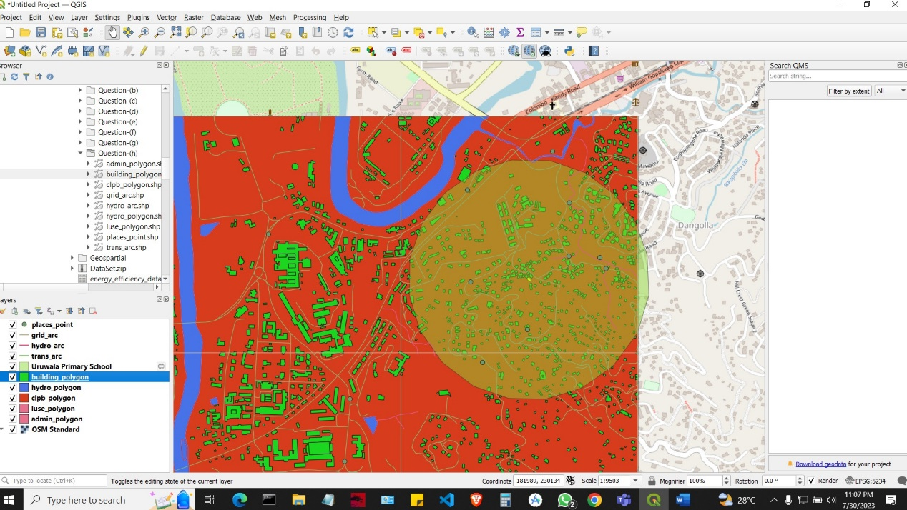

* 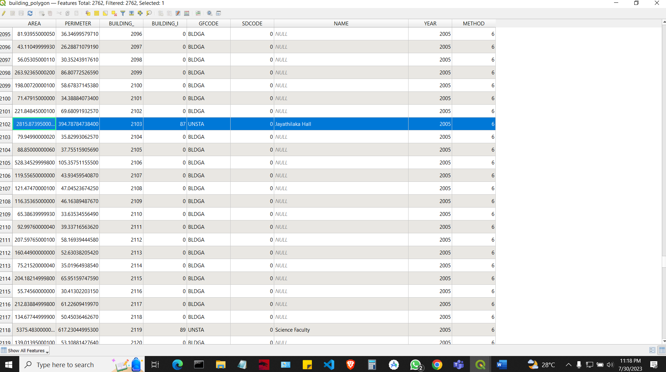**Find Jayathilaka Hall**

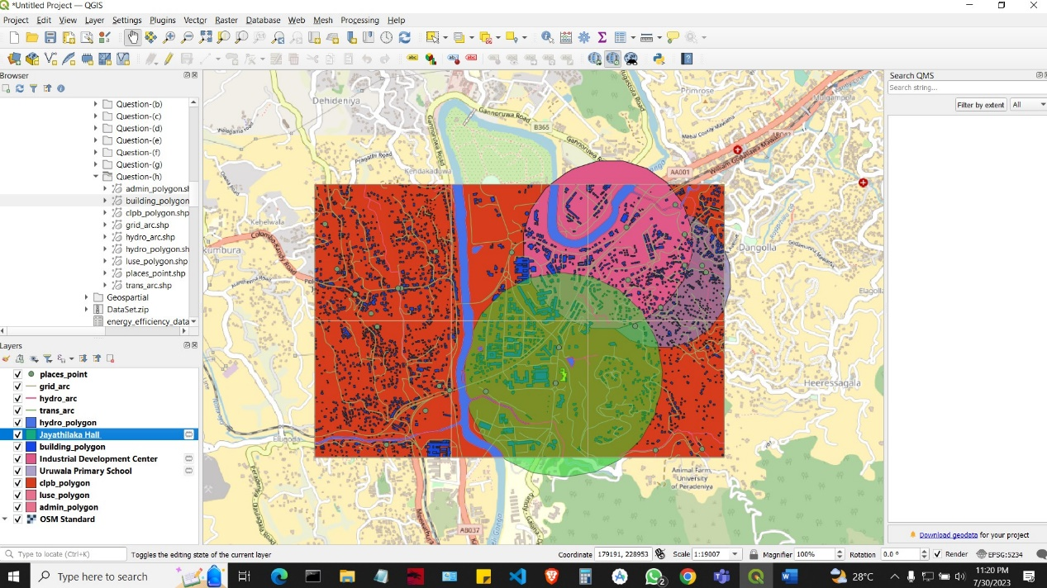

* 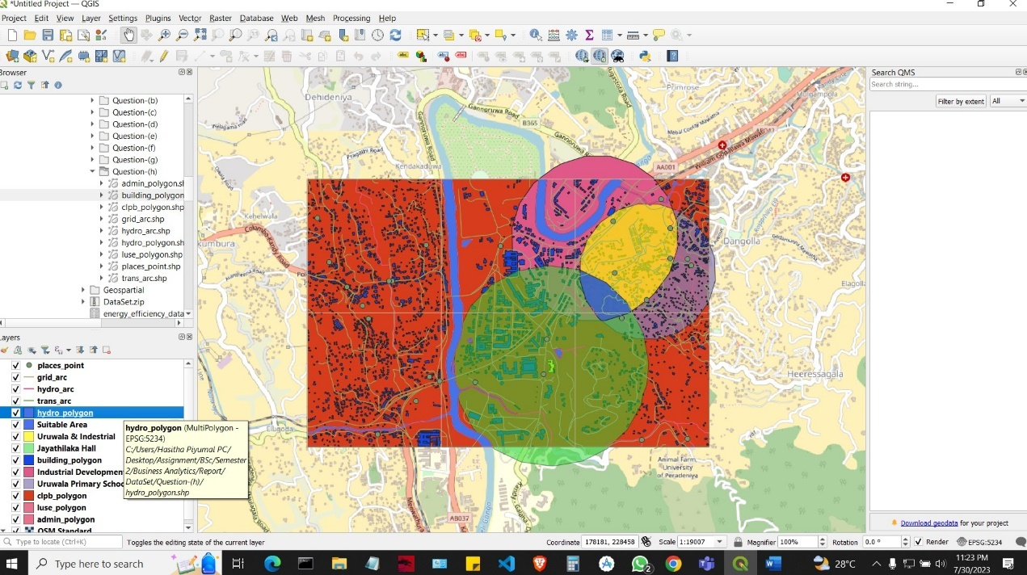After clipping find suitable area
* Create an Intersection

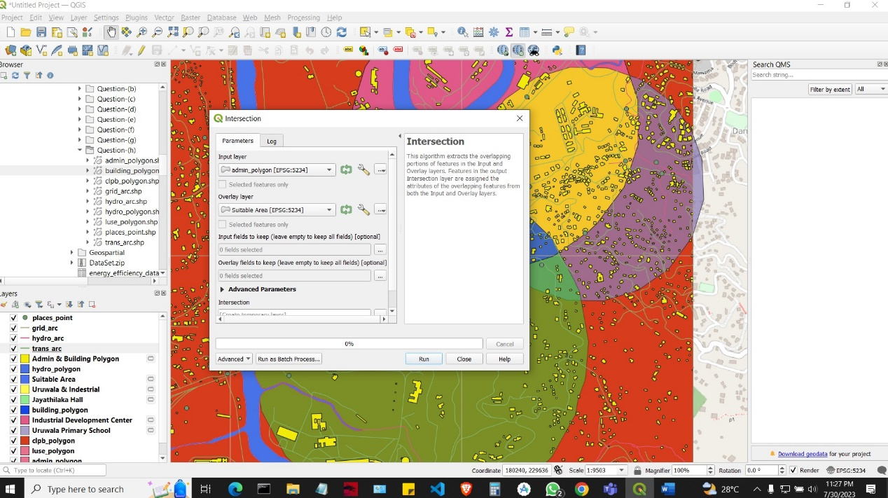

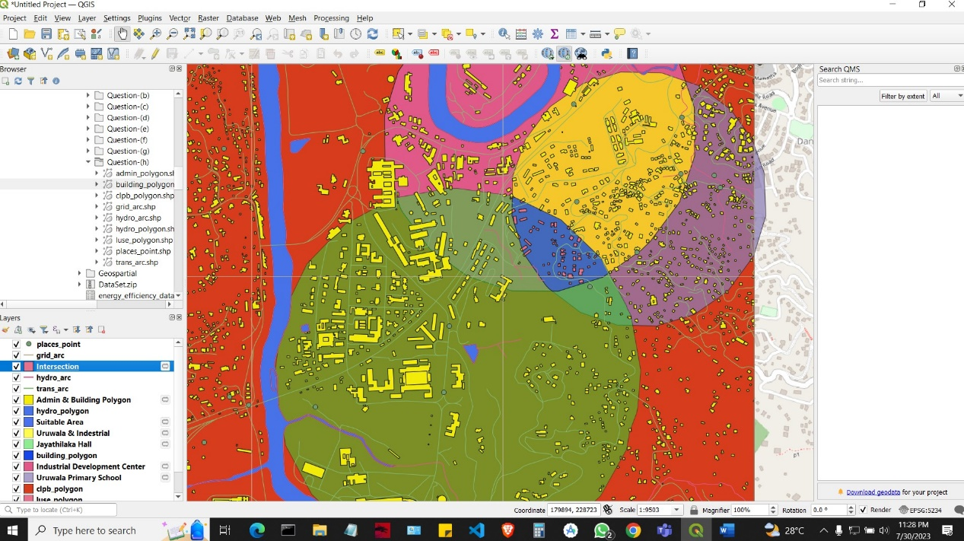

* Total land area

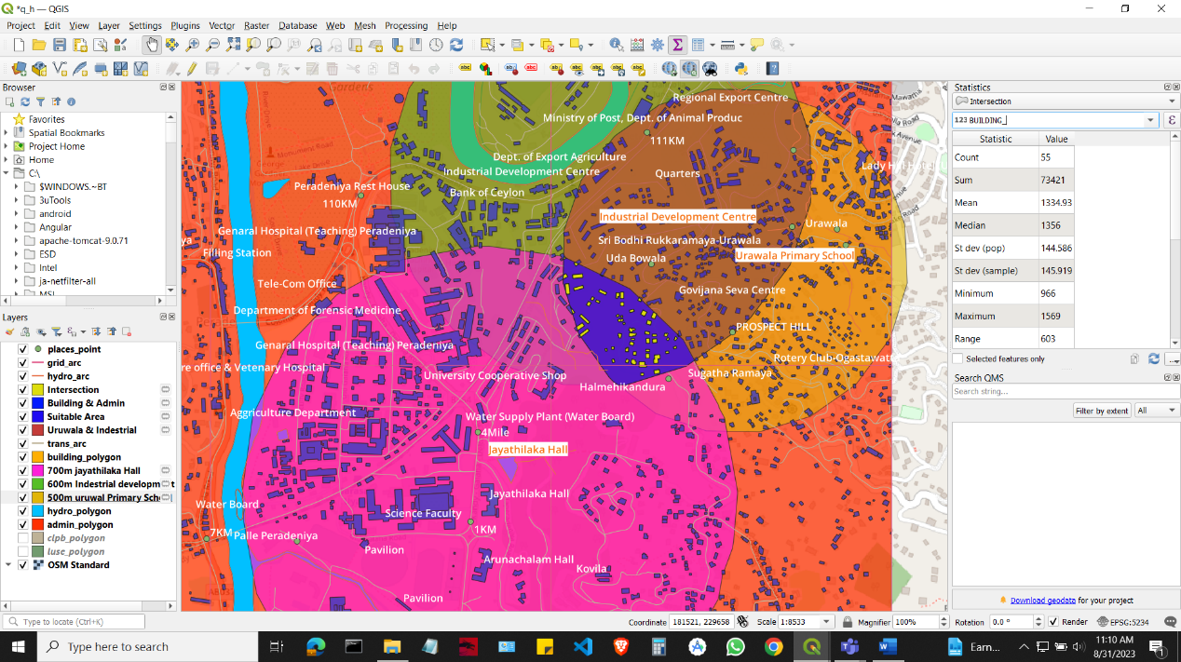

* Total suitable land area and building count

